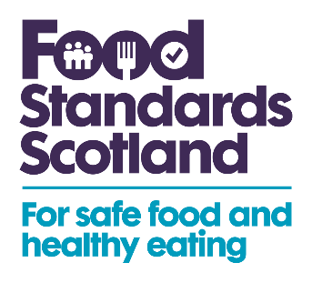

Consultation on proposed changes to domestic law in relation to EU Directives (Scotland only) on animal feed, food contact materials and extraction solvents

Summary of stakeholder responses

23 November 2022

Introduction

This consultation was launched on 12 September 2022 and closed on 10 October 2022. This report is a summary of the FSS consultation responses and replies to these.

This consultation sought stakeholders’ views, comments and feedback in relation to FSS proposals to correct deficiencies in domestic legislation relating to animal feed, food contact materials and extraction solvents. This is to ensure legislation operates effectively following the UK’s exit from the European Union (EU). Similar consultations were launched in Wales and England.

This consultation was sent to 129 subscribers. The consultation was published on the Food Standards Scotland website, circulated to enforcement and local authorities, and directly emailed to the relevant stakeholders who are likely to be affected by, or to have an interest in, the proposed amendments to feed, food contact materials and extraction solvents regulations.

FSS is grateful to those who responded. The comments, together with FSS’s responses to these, are set out in the tables below.

Characteristics of respondents and summary of responses

This consultation received 1 response. This was in relation to the amendments to domestic legislation for extraction solvents. This response was received from the UK Flavour Association.

A list of those who responded can be found below.

Summary of substantive comments and FSS response

Specific responses

Question 16: Do you agree that a full incorporation of Annex I of Directive 2009/32/EC into domestic legislation would provide ease of reference for enforcement authorities, industry and the public?
Respondent | Comment | FSS Responses
UK Flavour Association | In agreement – the UKFA fully supports the incorporation of existing levels into UK law | Comments noted.

Question 17: Are you aware of any impacts of the proposed measures that have not been identified in this consultation?
Respondent | Comment | FSS Response
UK Flavour Association | As Industry has been operating with the current list for some time we do not see any significant impact on cost to business with this technical change to the legislation | Comments noted.

Question 18: Do you agree that the familiarisation cost would be minimal. If not, please explain why?
Respondent | Comment | FSS Response
UK Flavour Association | Yes | Comments noted.

Question 19: Are there any other changes that would help to provide greater clarity on regulating the use of extraction solvents? If yes, please explain what these are and what benefits they may provide.
Respondent | Comment | FSS Response
UK Flavour Association | No | Comments noted.

Next Steps
- These responses will feed into the FSS’s recommendations to Ministers that the proposals are enacted and the relevant legislation is passed.

List of Respondents
This list does not include those respondents who asked for their response to be kept confidential or responses from individuals.
- UK Flavour Association (UKFA).

