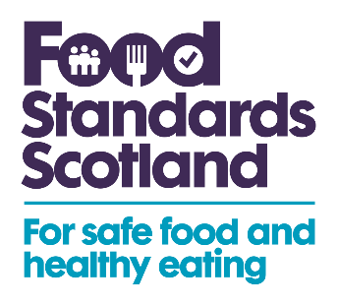

Consultation on applications for authorisation of six novel foods

Summary of stakeholder responses

The reach from this consultation was comprehensive, achieved through subscription alerts, social media posts and directly contacting stakeholders. This consultation was sent to 91 subscribers. Key stakeholders whose businesses or organisations are likely to be affected by, or to have an interest in, these novel foods were contacted directly for their feedback. To ensure representation across a broad spectrum of opinion, stakeholders with a range of interests in infant nutrition, were included. This consultation generated 621 impressions on Twitter, 401 impressions on LinkedIn and 819 impressions on Facebook. This consultation was also shared with the FSA’s 58,300 Twitter and 87,200 LinkedIn followers.

No responses were received for this consultation.

A second consultation, containing amendments to some of the opinions on these novel foods, was held between 31/03/22 and 13/04/22. You can find the content of that second consultation and the responses to it here.

