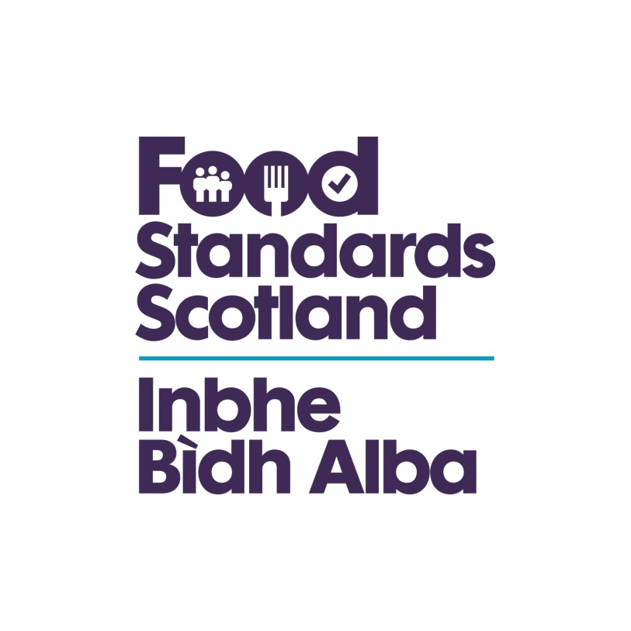

DRAFT BUSINESS AND Regulatory Impact Assessment

Foods For Special Medical Purposes For Infants, Infant Formula and Follow-on Formula And Addition Of Vitamins And Minerals (Scotland) Regulations 2019

Date: 1 November 2019
Stage: Consultation
Source of intervention: EU
Type of measure: Regulation
Contact for enquiries: Siobhan Watt
01224 285112
Siobhan.watt@fss.scot



- Title of Proposal
Foods For Special Medical Purposes For Infants and Addition Of Vitamins and Minerals (Scotland) Regulations 2019
- Purpose and intended effect
- Objectives
The purpose of the SSI is to:
- Enable the enforcement of and provide penalties for non-compliance with Article 8 and Annex III of 1925/2006 which lists substances whose use in foods is prohibited, restricted or under community scrutiny.
- amend the Foods for Specific Groups (Scotland) Regulations 2016 to:
- implement and mirror and enforce the Delegated Regulation 2016/128 rules on Foods for Special Medical Purposes (FSMP Regulation) for infants
- implement and mirror and enforce the Delegated Regulation 2016/127 rules on infant formula and follow-on formula (IFFOF Regulation)
- implement and enforce Article 15 and the Annex to the Foods for Specific Groups Regulation 609/2013 (FSG Regulation) with regard to the Union list of substances that can be added to FSMP for infants and IFFOF
- repeal the Foods for Special Medical Purposes (Scotland) Regulations 2000 from 22nd February 2020
- repeal the Infant Formula and Follow-on Formula Regulations (Scotland) 2007 from 22nd February 2020 as it applies to IFFOF, other than IFFOF made from protein hydrolysates for which it will repeal the 2007 Regulations from 22nd February 2021.

- Background
Addition of Vitamins, Minerals and Other Substances
The Addition of Vitamins, Minerals and Other Substances (Scotland) Regulations 2007 provides for the enforcement of Regulation (EC) No 1925/2006 on the addition of vitamins and minerals and of certain other substances to foods “the EC Regulation”.
Article 8 and Annex III of the EC Regulation provide for substances that could represent a potential risk to consumers. Such substances may be:

- Prohibited under Part A of Annex III
- Restricted with certain conditions of use under Part B of Annex III
- Kept under scrutiny subject to evidence of safety under Part C of Annex III.

These provisions are directly applicable in Scotland as an EU Member State. If we have exited the EU when this amendment is made, the EC Regulation will have been mirrored in UK law, so the provisions will continue to be applicable.

However, an omission in the Scotland Regulations meant that the Article 8 and Annex III provision was not included in the offences and penalties section of the original instrument.

FSS is therefore consulting on the proposal to amend the Scotland Regulations to include a provision for Article 8 on the prohibition or restriction of substances listed in Part A or B of Annex III. This will make it a punishable offence if a food business operator uses a prohibited substance listed in Part A or is non-compliant with the conditions of use for substances listed in Part B.
Food for Specific Groups (FSG)
The Food for Specific Groups Regulation (EU) No. 609/2013 (the FSG Regulation) lays down general compositional and information requirements for four categories of food, including FSMP, IFFOF, baby foods and foods for weight control. It is enforced in Scotland by the Food for Specific Groups (Scotland) Regulations 2016 (“the 2016 Regulations”).

Food for Special Medical Purposes (FSMP)
Delegated Regulation (EU) 2016/128 on Food for Special Medical Purposes (FSMP) supplements the FSG Regulation with the specific compositional and information requirements for FSMP taking into account the provisions of earlier harmonised legislation on FSMP (Directive 1999/21/EC).

It was adopted on 25 September 2015 and the provisions for FSMP other than FSMP for infants have applied since 22nd February 2019. These are enforced by the Foods for Specific Groups (Medical Foods) (miscellaneous Amendments) (Scotland) Regulations 2018, which amends the 2016 Regulations to include the provisions for FSMP (other than FSMP for infants).

Therefore, the FSMP Delegated Regulation 2016/128 has applied and been enforced in Scotland since 22 February 2019, except in respect of FSMP developed to satisfy the nutritional requirements of infants for which it is due to apply from 22 February 2020.

The SSI will implement and enforce the rules on FSMP for infants and repeal the Regulations that implement the earlier Directive i.e. the Foods for Special Medical Purposes (Scotland) Regulations 2000

Infant Formula and Follow-on Formula (IFFOF)
Delegated Regulation (EU) 2016/127 on Infant Formula and Follow-on Formula (IFFOF) supplements the FSG Regulation. It was adopted on 25 September 2015 to update the specific compositional and information requirements for IFFOF, taking into account the provisions of earlier harmonised legislation on IFFOF (Directive 2006/141/EC) and the latest scientific evidence.

Delegated Regulation (EU) 2016/127 on IFFOF is due to apply from 22nd February 2020, except in respect of IFFOF made from protein hydrolysates for which the provisions are due to apply from 22nd February 2021. We are consulting on enforcement of both the 2020 and 2021 provisions.

The SSI will implement and enforce the new IFFOF rules and will repeal the Regulations that implement the earlier Directive i.e. The Infant Formula and Follow-on Formula (Scotland) Regulations 2007 from 22nd February 2020 for the majority of IFFOF. However, The Infant Formula and Follow-on Formula (Scotland) Regulations 2007 will continue to apply in respect of IFFOF made from protein hydrolysates until 22 February 2021.

Union list of substances that can be added to Food for Specific Groups
Article 15 and the Annex to the FSG Regulation 609/2013 provide the Union list of substances that can be added to FSMP for infants and to IFFOF. This provision and the Annex are set to come into force from the date of application of the Delegated Regulations. Therefore this SSI will also implement and enforce this provision.

EU Exit
The UK is due to leave the EU on 31 January. However, in the event of a negotiated EU exit with an agreed Implementation Period or a further extension to Article 50, the UK Government and devolved administrations would be legally obligated to implement the remaining part of Commission Delegated Regulation 2016/128 and part of Commission Delegated Regulation 2016/127 which apply from 22 February 2020. i.e. marking the end of a 4 year transition period. In either of these scenarios, to ensure Scottish Ministers meet their EU statutory obligations, secondary legislation in Scotland would be required to provide for the execution and enforcement of the Delegated Regulation. In any case, given that the UK supported these Regulations during the negotiation stages and businesses are already working to its requirements, the policy intention is to adopt the updated rules in this area

- Rationale for Government intervention
The UK agreed the provisions of these Delegated Regulations when they were adopted in 2015 and intends to abide by the new rules which reflect the latest scientific evidence. In addition, industry has been working to meet the changes since 2015 and many manufacturers are already meeting these new requirements. As such, this SSI will copy into Scottish law the adopted EU provisions for FSMP for infants and IFFOF as they stand on Exit day and provide the enforcement regime for non-compliance.
Article 8 and Annex III of EC Regulation 1925/2006 are currently directly applicable in Scotland as an EU Member State. However, an omission in the Scotland Regulations meant that the Article 8 and Annex III provision was not included in the offences and penalties section of the original instrument.

FSS is therefore consulting on the proposal to amend the Scotland Regulations to include a provision for Article 8 on the prohibition or restriction of substances listed in Part A or B of Annex III. This will make it a punishable offence if a food business operator uses a prohibited substance listed in Part A or is non-compliant with the conditions of use for substances listed in Part B.

- Consultation
- Within Government
This consultation package was discussed with Scottish Government (SG) officials from Child and Maternal Health and Food, Drink and Trade teams.
- Public Consultation
A shortened 4 week consultation will be carried out in Scotland on the draft national legislation from 5th November 2019 to 2nd December 2019
- Business
The main new EU policy requirements will be contained within the specified regulations and this statutory instrument in effect just reinstates the previous enforcement provisions within the new framework, therefore we anticipate the impact to be minimal. Our initial engagement with industry has not raised any concerns.
Nonetheless, our consultation will request details of any known businesses impacted by the proposed SSI. It will be circulated to a wide group of industry bodies, retailers and enforcement officers who’s local knowledge may be able to identify manufacturers of foods for specific groups within Scotland.
The UK agreed the provisions of these Delegated Regulations when they were adopted in 2015 and intends to abide by the new rules which reflect the latest scientific evidence. In addition, industry has been working to meet the changes since 2015 and many manufacturers are already meeting these new requirements. Therefore for Scottish businesses more generally, the only likely impact will be a familiarisation cost associated with the proposed regulations. This includes reading and disseminating information to key staff within the organisation.

- Options
Option 1 – Do nothing. This means that the legislation that businesses have been working towards since 2015 would not be directly applicable European Regulation could not be enforced in Scotland.
Option 2 – Introduce legislation to implement and provide enforcement provisions in Scotland for the above Delegated Regulations and Regulation.
- Sectors and groups affected
While these proposed regulations apply to Scotland only, separate enforcement regulations will be introduced in England, Wales and Northern Ireland; as such the impact on the UK as a whole has been assessed.
Consumers – Non-monetised benefits to consumers from the establishment of clear definitions, composition and labelling of infant formula and follow-on formula, food for special medical purposes and increased safety with the enforcement of substances whose use in foods is prohibited, restricted or under community scrutiny
Enforcement Authorities – enforcement of the rules on foods for specific groups and the addition of vitamins and minerals is the responsibility of Local Authority Environmental Health Services.
Businesses – Manufacturers and retailers will be the main groups affected by the Foods For Special Medical Purposes For Infants And Addition Of Vitamins And Minerals (Scotland) Regulations 2019

- Benefits
Option 1
With this option enforcement authorities would not have to familiarise themselves with these new regulations. As businesses have been working towards the FSG requirements for a number of years, there are no benefits associated with maintaining the currently regime.
Option 2
As businesses have been working towards these requirements for a number of years and products meeting the Regulations are already being placed on the market, they will be able to continue on without having to revert back to previous formulations. This allows for easier trade if they wish to trade with the EU at a later date. This option would also result in the domestic market and export market (to EU) complying with the same regulations therefore it would minimise related export enquiries for enforcement authorities. Although these proposals do not affect consumers directly, it is worth nothing that these regulations will maintain the high level of consumer protection.

- Costs
Businesses – Option 1
If businesses are required to revert to previous formulations for the UK market then there are likely to be large costs associated with maintaining two different formulations for the UK and EU markets. We will try to ascertain these costs in our consultation
Businesses - Option 2
There is expected to be a one-off familiarisation cost for businesses. This figure is calculated by firstly taking the 2018 Provisional ONS ASHE (Annual Survey of Hours and Earnings) median figure for “production managers and directors” £21.82 – averaging approximately £28.37 per hour once uprated to account for non-wage labour costs and overheads, taken as 30%. It is estimated that the reading and understanding of the EU Regulation and the proposed regulations will take two hours with a further two hours for dissemination to key staff within each firm (a total of 4 hours). This would yield an approximate one-off familiarisation cost of £113.46 per business.
Consumers – Option 1
If businesses no longer require to comply with the changes, they may revert their recipes back and the cost of reformulating products may be passed onto consumers.
Consumers – Option 2
As businesses have been working towards these requirements for a number of years there is not expected to be a significant change to costs that will affect consumers.

Enforcement Authorities – Option 1
No costs associated as the regulations would not require enforcement.
Enforcement Authorities – Option 2
There are 32 local authorities in Scotland. It is estimated that each officer is expected to read and familiarise themselves with the Regulations and the proposed domestic regulations and that it may take two hours to do so.
There are currently approximately 350 environmental health officers in Scotland, and the median hourly pay rate for an environmental health officer is £18.87 - averaging approximately £24.53 per hour once uprated to account for non-wage labour costs and overheads, taken as 30%.
The total one-off cost to the 32 local authorities is therefore estimated at approximately £17,172.
- Scottish Firms Impact Test
Various Scottish businesses of different sizes and from various geographical areas will be approached during the public consultation period to seek their views on the likely impact on their business of the changes proposed. They will be requested to consider all questions posed in this partial BRIA and assess the cost estimates.
- Competition Assessment
The proposed legislation will apply to all businesses and individuals involved in foods for special medical purposes for infants, infant formula and follow-on formula and those who are involved with vitamin, mineral and certain other substance fortification equally, allowing them to trade across EU Member States, if appropriate. It should not limit the number or range of suppliers in Scotland either directly or indirectly or reduce the ability of, or incentives to, suppliers to compete. Therefore, it is not expected to have a significant impact on competition.
Using the Competition and Markets Authority competition assessment framework developed by the former Office of Fair Trading, it has been established that the preferred policy option (Option 2) is unlikely to have any material negative impact on competition. We assert that this policy will not limit the number or range of suppliers directly or indirectly nor will it limit the ability or reduce incentives of suppliers to compete vigorously.
- Test run of business forms
No new or additional forms will be introduced by this proposal therefore no test run need be completed.
- Legal Aid Impact Test
During the consultation period we will ascertain with the Justice Directorate whether the new regulations will have any legal aid implications.
- Enforcement, sanctions and monitoring
- Enforcement
Enforcement of the Regulations in Scotland will be the responsibility of local authorities. In Scotland, Enforcement Officers from Local Authority Environmental Health Services will need to familiarise themselves with the new requirements and ensure they are adhered to. Enforcement action is only pursued where informal action has been unsuccessful.
- Sanctions
It is anticipated that Foods For Special Medical Purposes For Infants, Infant Formula and Follow-on Formula And Addition Of Vitamins And Minerals (Scotland) Regulations 2019 will insert an offence with the associated penalties as per Regulation 4 of The Addition Of Vitamins and Minerals and Other Substances (Scotland) Regulations 2007.
- Monitoring
The effectiveness and impact of the regulations will be monitored via feedback from stakeholders, including Enforcement Agencies, as part of the ongoing policy process. Agency mechanisms for monitoring and review include; open fora, stakeholder meetings, surveys and general enquiries.

Contact point
Siobhan Watt

Regulatory Policy Branch
Food Standards Scotland
3rd Floor, Pilgrim House, Old Ford Road, Aberdeen, AB11 5RL
Tel: 01224 285112
e-mail: siobhan.watt@fss.scot

https://www.ons.gov.uk/employmentandlabourmarket/peopleinwork/earningsandworkinghours/datasets/occupation4digitsoc2010ashetable14
figure taken from the provisional 2018 ONS ASHE (Annual Survey of Hours and Earnings,https://www.ons.gov.uk/employmentandlabourmarket/peopleinwork/earningsandworkinghours/datasets/occupation4digitsoc2010ashetable14

