Verification of Food Safety Management Systems: Principles for Official Controls in the Approved/Manufacturing Sector

(Draft For Consultation)

This document has been produced by the Scottish Food Enforcement Liaison Committee’s (SFELC) Approved Establishment Working Group, which is comprised of officers with experience in food safety inspection and control within the Approved Establishment sector. The guidance also draws upon existing good practice amongst Competent Authorities and within the commercial inspection sector.

CONTENTS

 | Page
Part 1 – General Introduction and Overview of the Inspection Process | 3
General Scope, Aims, Objectives and Background of this Guidance
Part 2 - Overview of the Inspection Process | 10
Part 3 - The procedural stages of the Inspection process | 21
Inspection Stage 1 - Preparation for the Inspection | 27
Inspection Stage 2 - The Opening Meeting | 30
Inspection Stage 3 - The Main Inspection – onsite verification and validation | 32
Inspection Stage 4 - The Closing Meeting | 37
Inspection Stage 5 – Evaluation of Observations | 40
Inspection Stage 6 – Inspection Report | 41
Part 4 – The official control HACCP study | 42
Guidelines on conducting an official control HACCP study
Glossary | 65
Annex A – Codex HACCP Steps | 67
Annex B – Business Profiling | 68
Annex C – Random Number Page | 69
Annex D – Resource Requirements | 70
Annex E – Further Resources | 75
Annex F – Model Inspection Forms | 76
Acknowledgements | 133

PART 1

GENERAL INTRODUCTION

1.1 Scope of this Guidance

This document promotes the implementation of certain broad principles which may be used when verifying food safety management systems (FSMSs) during Official Controls within approved and certain other manufacturing establishments. This sector is of major strategic importance within the Scottish food sector and the Scottish economy more widely. It is also recognised that the verification of FSMSs in the complex context of manufacturing is an onerous task. It is, therefore, considered appropriate to define certain broad principles of effective verification upon which to base effective and consistent inspection procedures. The document encompasses the verification of all elements of FSMS including the prerequisite programmes, traceability, FBO HACCP Studies, HACCP plans and product description elements.

These core principles relate both to the initial approval process as well as to routine full inspections and other Official Controls undertaken following approval.

It is proposed that the document will be applied in its entirety at least once during each inspection cycle post-approval. In practice this is likely to require multiple visits, using the ‘bite sized chunks’ and random sampling approach referred to later in this document, to ensure that the FSMS is verified.

Due to the diversity of manufacturing and processing establishments, the document is essentially generic in nature when defining general principles which Competent Authorities will use when they carry out their inspection duties. However, examples of specific processes are used to illustrate certain aspects of the approval/inspection process. The guidance is considered to be less applicable to establishments which manufacture lower risk, non-ready-to-eat foods.

In addressing FSMSs, this document embraces notions of Food Hygiene, Food Standards, Food Fraud and General Food Law. This approach integrates issues such as, Article 5 of Regulation (EC) 852/2004(Hazard analysis and critical control points), allergens, labelling and product disposition control within the scope of the FSMS.

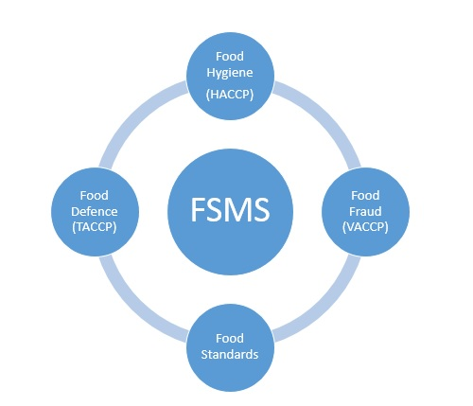

Figure 1 Considerations within Food Safety Management Systems

1.2 Aim of this Guidance

The aim of this document is to provide guidance to Competent Authorities on the verification of FSMSs in general terms and, more specifically, of those within establishments subject to Regulation 853/2004 – i.e. Approved Establishments. In particular, it aims to provide assistance when verifying compliance with Article 5 of Regulation 852/2004.

1.3 Objective of the Guidance

The objective is to represent a systematic, science-based approach to verifying FSMSs. The framework is designed to apply the Guidance on the Regulatory Assessment of HACCP published by the WHO/FAO. Accordingly, the guidance closely integrates the concept of the HACCP Study and auditing techniques into the inspection process.

This document acknowledges that the implementation of WHO-CODEX HACCP per se is not a legal requirement for each business; rather it requires that the HACCP Study is closely integrated into auditing techniques.

The WHO Codex guidelines on the Validation of Food Safety Control Measures confirm that the verification of FSMSs requires the validity of control measures to be assessed and verified. Consequently, the assessment of validation is emphasised in this document.

This document is not intended as a guide to HACCP. Nor is it designed to be a replacement for training and an in-depth knowledge of HACCP and FSMS auditing. (Both are considered to be essential core skills for the verification of FSMS in Approved Establishments).

1.4 Background

This document seeks to reinforce the principle that the effectiveness of a FSMS is of paramount importance in the protection of consumers against food borne illness and that the verification of FSMSs during Official Controls is conducted systematically and with scientific rigour. In effect, it is designed to ensure that FSMSs are verified both in terms of their validation and of their implementation.

Hazard Analysis and Critical Control Point (HACCP) is an internationally recognised, systematic approach to assuring food safety. Accordingly, this document steers officers towards a similarly systematic inspection process incorporating HACCP as an inspection tool. Officers are guided towards the use of the techniques of cross-referencing and triangulation between the three ‘cardinal points’ of reference which are integral to the verification of FSMSs. In so doing, the certainty in the verification of the safety of a food production process and the relevant FSMS is enhanced.

The conduct of a gap analysis, incorporating all of the three cardinal points listed above is used to verify the safety of the operation.

1.5 Pre-Inspection Considerations

1.5.1 National Advice

It may be appropriate for officers to access relevant central advice whilst preparing for an inspection. Potential sources for advice are

    - Trade organisations advice relevant to a particular type of premises;
    - Specific Food Standards Agency/Food Standards Scotland advice – letters or guidance documents;
    - Information and advice about product recall, food alerts etc. on the FSS/FSA Website;
    - FSA/FSS/SFELC aide memoirs/inspection forms.

1.5.2 Additional Expertise

It is essential that the officer has an adequate level of knowledge of the relevant hazards and the food science and technological aspects associated with the products and processes – prior to the Official Control HACCP Study and the visit. It is possible that additional expertise may be required, e.g. when inspecting complex or novel food processing operations or perhaps following an inspection where problems have been identified which require specialist knowledge. Sources of additional advice include:

    - The Food Standards Agency;
    - Food Standards Scotland;
    - Food Scientists/Technologists;
    - Food Examiner (including microbiological issues and chemical controlling factors and preservatives);
    - Public Analyst – e.g. for advice on compositional issues, foreign bodies, contamination etc.;
    - Other Local Authorities with relevant establishments/processes.
    - SFELC List of Sector Specialists

A list of further resources can be found in Annex E

1.5.3 Home/Primary Authority Considerations

Officers should consider how their inspection approach could differ when they are inspecting local outlets of multi-site businesses. It may be appropriate to enquire from the relevant Home or Primary Authority, the nature of any FSMS and how division of responsibility for its application is delivered. Issues to be considered include:

- Where do the responsibilities for the management and co-ordination of the FSMS lie?
- To what extent are responsibilities devolved to local branch level?
- Is relevant information available on business’ websites? E.g. details of routine monitoring carried out by the business.

1.5.4 Timing, Advance Notice and Co-ordination of Inspections

Officers should consider the following:

- The optimum time to view specific processes or operations;
- The need for occasional out-of-hours visits during evenings or weekends; i.e. when inspections are ‘not expected’;
- The need to speak to a particular person; e.g. the Food Business Operator (FBO) or the Quality Assurance Manager; and
- The need for an appointment.

Officers should consider the need for advanced notice of an inspection and note that in most cases, food hygiene inspections should be unannounced.

“Official Controls shall be carried out without prior warning, except in cases such as audits where prior notification of the feed or food business operator is necessary …”

EC Regulation No. 882/2004, Title II, Chapter I, Article 3, Point 2

It is acknowledged, however, that to apply this document in full it will be advantageous or necessary in many establishments to give advance notice of at least one of the inspections in each inspection cycle. For example, at some relatively large manufacturing premises, where minimal but prior notice of inspection may be needed to ensure that the appropriate management and/or technical representatives are present for the inspection. Alternatively, in some small operations, the only person with sufficient overview of the business may be absent – unless prior notice is given.

1.5.5 Joint and Combined Inspections

Given the comprehensive nature of inspections in approved establishments and the need to focus on key food safety issues, it is recommended that joint visits to such premises are not undertaken with other enforcement agencies. Similarly, it is recommended that food standards inspections should be undertaken at a different time.

1.6 Resource requirements

To allow effective planning of inspections and effective allocation of resources, it is necessary to estimate the time required to undertake inspections in accordance with this document.

A standard method, based on ISO 22003:2007, for estimating the minimum time required for an inspection can be found in Annex D.

Table 1 - Implementation Summary Table

Inspection Stage | Match to Codex HACCP Steps | Aims | Verification Activities | Activities/Inspection Tools
Stage 1 - Preparation for Inspection | Review of HACCP Steps 1 – 12 (carried out off site) | Business Profiling  File/Document Review  FSMS Review  Evaluation of the validation Process  Planning the Inspection  Defining the scope of the inspection | Verifying the HACCP Team  Verification of the product description  Verifying identification of hazards  Verifying the use of pre requisite programmes  Verification of the effectiveness of control measures  Verification of the determination of CCP’s  Verification of the verification process. | Issue Pre-Inspection Documentation Schedule  Gap Analysis between FBO’s FSMS and Official Control HACCP Study  Hazard Mapping  CCP Decision Tree  Pre-Requisite Decision Tree
Stage 2 - Opening Meeting | HACCP Steps 1 – 12 | Confirm the accuracy of the business profile held on file.  Identify and account for changes in the business profile.  Clarify matters which have arisen during stage 1. | Verifying the HACCP Team  Validation of the flow diagram  Verify Validation and verification | Random Sampling  Walking the line to verify process flow.
Stage 3 - The Main Inspection | Verification of all aspects of FSMS (HACCP Steps 5 - 12) | Review of the relevant documentation relating to the FSMS and assessment of their adequacy and accuracy.  Physical examination of processes, practices and records to assess whether the operation is valid and compliant with the documented system. | Verifying the flow diagram  Verifying critical limits, monitoring, corrective actions and record keeping  Verifying product disposition  Verifying product recall | Mass Balance Approach  Walking the Line  Random Sampling  Gap Analysis between FBO’s FSMS, OC HACCP Study and Reality.  Tracking and Tracing  Interviews with employees  Observations  Review of live records  Mock product recall
Stage 4 - Closing Meeting | HACCP Steps 1 – 12 | Emphasise any non-compliance.  Identify a corrective action plan. |  | Risk Quadrant
Stage 5 – Evaluation | HACCP Steps 1 – 12 | Evaluation of observations to guide enforcement actions consistent with Food Law Code of Practice. |  | Risk Quadrant
Stage 6 – Report | HACCP Steps 1 – 12 | Documentation of the inspection findings in accordance with the Food Law Code of Practice.

There will be a natural overlap between some activities of the Preparation and Opening meeting phases
The early phases of the main inspection are likely to overlap with the Opening meeting.

PART 2

OVERVIEW OF THE INSPECTION PROCESS

2.1 Aims of the Inspection Process

The ultimate aim of a food safety inspection is to verify the safety of the food production process and thus protect the consumer from foodborne illness.

2.2 Objectives of Inspection

The objectives of the inspection process are to establish whether:

- The FSMS is capable of controlling all food hazards;

- Appropriate prerequisite programmes have been defined in relation to generic processing hazards;

- Appropriate systems have been defined in relation to controlling food-specific hazards; and

- The FSMS is capable of accounting for and controlling the disposition of food products, non-conforming products, waste products and packaging.

Two key questions which must be addressed are:-

Validation - is the FSMS valid?

Are the measures proposed or taken by the FBO capable of satisfying food safety requirements? Are the components of the FSMS including analysis of hazards, control measures, critical limits, monitoring activities, corrective actions, documentation systems and disposition management systems actually valid and appropriate for the production of safe food?

Verification - is the FSMS verified?

Is the FSMS doing what the FBO says it should be doing? Are the components of the FSMS including analysis of hazards, control measures, critical limits, monitoring activities, corrective actions, documentation systems and disposition management systems actually being carried out in reality?

2.3 Overarching Approach to Verification

These two overarching questions above can only be answered by reference to and comparison between the three Cardinal Points.

The officer should use acknowledged inspection and auditing techniques to verify the adequacy, suitability and appropriate implementation of the FSMS. There are two key processes involved:

- Cross Reference between the Officer’s HACCP Study and the FBO’s FSMS; and

- Reality Check – Where the inspector actively observes implementation of the FSMS in practice, and cross references actual practice with his/her own HACCP Study.

Overall, inspection is essentially a process of ‘triangulation’ between the Official Controls HACCP study, the FSMS and the operation in practice.

The Official Control HACCP Study plays a crucial pivotal role, by proving a reference point that is external to the FSMS and the operation of the establishment, wherefrom the validity of the FSMS can be verified. This avoids the error of simply verifying the implementation of invalid FSMSs, i.e. the HACCP principles are integrated into the inspection methodology (described in subsequent sections) enabling the officer to verify the ‘HACCP Study’ conducted by the business itself.

2.3.1 The process of official control verification

This process forms a standard against which the FBO’s own HACCP study can be validated and verified.

The Triangulation and Cardinal Points concepts are represented in overview in Figure 2 below.

FBO’s FSMS
Figure 2

Reality check
(Incl. Cross-reference/analysis)

Cross-reference/analysis

GAP
ANALYSIS

Official Control HACCP Study
Implementation of
FBO’s FSMS

Reality Check (incl. Cross-reference/analysis)

Figure 2 represents a process of GAP Analysis between what are the three cardinal points of reference, relevant to the verification of a FSMS. This approach can be applied flexibly to any element within the FSMS.

The Gap Analysis process answers the key questions:

- Does the FBO say that he or she intends to do the right things?’
(Answered by Gap Analysis between the Official Control HACCP Study and the FBO’s FSMS – constitutes Verification of Validation); and

- Is the FBO actually doing what they he or she said that they intended to do?
(Answered by Gap Analysis between the FBO’s own HACCP Study and the Reality Check – constitutes verification of verification); and

- Is the FBO actually operating safely in the here and now?
(Answered by Gap Analysis between the Official Control HACCP study and the Reality Check). This process distinguishes an inspection from pure audit activity.

This last question also identifies those common situations, where the operation is actually functioning safely, but has deviated from the written FSMS, i.e. the FSMS ‘on paper’ has become invalid. This is common in small and medium establishments, where the operation is altered and the documented FSMS is revised afterwards. This process need not be inherently unsafe although it indicates a lack of rigour which could lead to loss of control in the future.

The processes of HACCP study and of GAP Analysis tend, as they are undertaken, to be simultaneous. The complexity of this operation is supported by adequate training, the Inspection Procedure and the use of a suitable Aide Memoir.

In reality, this process should be based upon a number of component triangulations, where each element of the FSMS is verified. The outcome of this process will amount to verification of the entire FSMS as above. (See text on Evidential Triangulation later within this section.)

2.3.2 Verifying the FBO’s FSMS

This process is intended to establish whether the proposed actions of the FBO are correct (this is carried out by checking FBO’s written documents, protocols, HACCP plans etc.). The validity of the FBO’s own FSMS is verified by a process of Gap Analysis between it and the Official Control HACCP study. Figure 3 represents this process.

Figure 3

FBO’s FSMS

GAP
ANALYSIS

Reality check (Cross-reference/analysis)

Cross-reference/analysis

Implementation of
FBO’s FSMS

Official Control HACCP Study

Cross-reference/analysis

Case Study 1- Invalid FSMS – Botulism caused by consumption of Hazelnut Yogurt

The largest outbreak of food borne botulism in the UK occurred in 1989, when 27 people were ill and one person died, after eating hazelnut yoghurt made with cans of hazelnut purée. The purée was the source of botulinum toxin.

The pH of the puree was >4.5 and the heat process employed in its manufacture was insufficient to destroy spores of C. botulinum. However, growth of C. botulinum would normally be inhibited by the low water activity (a_{w}) – as a consequence of the product’s sugar content. (Water activity is a measure of the amount of water which is available in foods for microbial growth.)

The product formulation of the puree was altered in the absence of a hazard analysis. Sugar was replaced by aspartame - which does not lower water activity to the same degree as sugar. These factors, together with storage of the purée at room temperature, permitted growth of the organism and production of toxin type B to levels of 600-1800 MLD/ml.

If conducted by a suitably trained officer within the appropriate time-frame, Official Control Verification would have been equipped to detect a ‘GAP’ between the Official Control HACCP study and the FBO’s FSMS in the form of HACCP Steps 2 and 6.

Case Study 2 – Invalid CCP – Haggis Manufacturer

An FBO producing haggis has established a CCP at the first temperature treatment. The main ingredients are boiled to achieve an internal temperature of at least 80°C for 45 minutes. Then the ingredients are diced, mixed and filled into casings to be boiled for further 30 minutes at 80°C. However, the last boiling point is not considered a CCP and there are no described Corrective Actions for this point. There is no clear procedure to explain how the product will be handled between the two points of temperature treatments without the risk of contamination.

The FBO failed to identify the correct CCP being the last temperature treatment.

Case Study 3 – Invalid Corrective Action – Metal Detection

A cake manufacturer produces individual cake slices packaged for the final consumer. All finished products pass through a metal detector for ferrous, non-ferrous and stainless steel. Monitoring using test pieces is carried out before packing, every half-hour and on completion of packing to ensure that the metal detector is operating correctly. The documented corrective action states that any product with metal detected will pass into a locked container for removal and investigation by quality control staff. However, this corrective action does not refer to the actual control e.g. the correct operation of the metal detector. The corrective action requires to identify the action to be taken in the event that the test piece is not detected during monitoring.

Case Study 4 – Invalid Critical Limit – Raw Milk Pasteurisation

An FBO proposes to manufacture ice cream from raw milk and forwards the HACCP plan and supporting documentation as part of the approval application process. The critical limit identified in the HACCP documentation for pasteurisation is 72°C for 15 seconds and therefore meets the legal requirement for HTST pasteurisation. However, the calibration record for the thermometer identifies a tolerance of 0.5°C which has not been taken into consideration. This could result in the actual temperature being as low as 71.5°C and the product not being pasteurised.

Case Study 5 – Inadequate Monitoring – Ready Meal Packing

A meat product manufacturer producing ready meals which are packaged in modified atmosphere. Pre-mixed CO/NO₂ is automatically filled into the packaging and the machine is designed to cut out in the absence of the gas. The packing process each day last approximately 2 hours and products are distributed later that day. The FBO’s FSMS states that a pre start up check is carried out to ensure that the fail safe is operating. Records demonstrate that this is carried out and the FBO demonstrates the procedure to the officer with competence. However, the officer notes that there is no further check either during or on completion of packaging to verify that the cut out is still operating. This may result in the distribution of product without gas present and therefore an unacceptable shelf-life.

2.3.3 Verifying implementation (Reality Check 1)

This process is intended to establish if the FBO is actually doing what he or she said that they intended to do.

Implementation is verified by a process of Gap Analysis between the FBO’s FSMS and the operation in practice. Figure 4 below represents this process.

Figure 4
FBO’s FSMS

Cross-reference/analysis
(Document Review)
Cross-reference/analysis
(Reality check)

Implementation of
FBO’s FSMS

Official Control HACCP Study

Cross-reference/analysis (Reality Check)

Case Study 6 – Reality Check - Salmonella typhimurium In Peanut Products

In late 2008 and early 2009, nine people died and at least 691 people fell ill in 46 US states due to food poisoning from eating products containing peanuts. Half of those affected were children. The illness was established to have been caused by Salmonella typhimurium.

A combination of epidemiological analysis and laboratory testing by state officials in Minnesota and Connecticut, the Food and Drug Administration (FDA), and the Centre for Disease Control and Prevention (CDC) confirmed that the sources of the outbreak were peanut butter, peanut paste, and peanut meal produced by the Peanut Corporation of America (PCA) at its Georgia processing plant. Significant on-going non-conformance with basic prerequisite programs, together with recurrent FBO authorised overrule of EPT based Positive Release systems (which had previously detected the presence of salmonella on several occasions) were the cause of the outbreaks.

If conducted within the appropriate timeframe by a suitably trained officer, Official Control verification would be equipped to detect a ‘GAP’ between the FBO’s FSMS and the operation in reality, in the form of prerequisite programmes and HACCP steps 6, 10 and 11.

Case Study 7 – Reality Check – Monitoring of Metal Detection

During an inspection of a wild game establishment, the authorised officer audits the HACCP for the production of small wild game breast fillets. The FBO’s FSMS states that their last CCP is the metal detection at the packaging stage.

During the inspection, the auditor discusses the methodology behind the metal detection checks and establishes that there is only one QA officer carrying out these checks. However, there are 3 lines used for packaging this product, most of the time working simultaneously. The monitoring sheets used have pre-printed times on them, all with 8 am, 12 pm and 16 pm. It is impossible for one person to carry out an elaborate test on 3 lines at the same time.

2.3.4 Verifying Implementation (Reality Check 2)

This process is intended to establish whether the FBO is operating safely at the time of the inspection and complements the reality check process described by Figure 4 above.

FBO’s FSMS
Figure 5

Cross-reference/analysis
(Reality check)

Cross-reference/analysis
(Document Review)

Implementation of
FBO’s FSMS

Official Control HACCP Study

Cross-reference/analysis (Reality Check)

Case Study 8 – Reality Check - Listeriosis Caused by Mexican Style Soft Cheese

In 1985, a California listeria outbreak led to 52 confirmed deaths, including 19 stillbirths and 10 infant deaths. This represented the deadliest recorded food-borne illness outbreak in the United States. The food vehicle was Mexican-style soft cheese made by the Jalisco Company in California. Jalisco had a non-licensed technician perform the pasteurisation process. It is believed that pasteurised milk was diluted with non-pasteurised milk by the same technician.

If conducted within the appropriate timeframe by a suitably trained officer, Official Control verification would be equipped to detect a ‘GAP’ between the Official Control HACCP study (which would have required the use of a licensed competent technician) and the operation of the process in reality, in the form of prerequisite programmes relating to training and authorisation and in the form of HACCP steps 4, 5, 8, 9, 10 & 11.

2.3.5 The Use of Elective and Random Sampling

FSMSs in larger or complex manufacturers are frequently very extensive in nature. It may be neither desirable nor an effective use of resources to verify the entire FSMS. Elective sampling and Random sampling offers a potential alternative whereby representative elements and specific elements of the FSMS are selected for verification.

2.3.5.1 Elective Sampling

Notwithstanding the need to representatively sample elements of the FSMS, certain elements will naturally be more significant than others such as those that address high risk products. The following are examples although this is not an exhaustive list:-

- All Critical Control points – including HACCP Steps 6 to 12
- All Operational Prerequisite programmes
- Validation of all control measures and of critical limits
- Process flow diagrams within high risk zones
- Rework operations particularly those related to corrective actions
- Waste disposal operations relating to high risk RTE foods
- Labelling of allergenic products
- Provenance and traceability of shellfish

Case Study 9 – Reality Check Elective Sampling of the FSMS

Whilst planning an inspection of a sous vide ready meal manufacturer and before the random sampling of elements of the FSMS are selected, the inspection officer considers the elements of the FSMS that address high risk products and elects to sample the following elements of the FSMS:-

- All critical Control points, including HACCP Steps 6 to 12
- The validation study supporting the Control Measure and the Critical Limits for cooking (i.e. time and temperature regime, mass of product and cooker loading parameters)
- The calibration status of the Sous Vide cookers.
- The process flow diagram relating to the high risk zone
- The training status of all personnel working within the high risk zone.

2.3.5.2 Random Sampling

For this approach to be valid, the representativeness of the sampling is critical. The elements of the FSMS that are selected for verification must be sufficient in number and also representative of the entire FSMS, i.e. they must be sampled without any bias (e.g. if plant does weekly microbiological testing of their own RTE products every week different RTE product should be sampled (frequency is based on risk, it is not a legislative requirement). Also best practice is to change the testing day as well (not always same day of the week). One approach is to utilise a random number page as in Annex C to select a random number and use this to select an element of the FSMS to verify.

Case Study 10 – Reality Check Random Sampling of the FSMP

During an inspection, an Officer attempts to verify that corrective actions are being undertaken by the FBO and that the FSMS is ‘live’ - in that the FBO is learning from any mistakes that are made. Whilst reviewing the ATP records, the Officer notes that, since the last inspection, there are 26 instances where the ATP-based verification of cleaning and disinfection has indicated a potential cross contamination hazard. Rather than verify each and every instance through an audit trail, the officer decides to select a sample of the ATP assays through random sampling. A random number generator is employed on a calculator and is used to select a representative sample of the total assays. The Officer selects the samples with reference numbers that correspond to the random number generator, dividing the random number appropriately where it is greater than 26. Such a process allows the officer to select without introducing bias and represents a sound basis for making deductions relating to corrective actions more generally.

2.4 Evidential Triangulation

This document strongly supports the use of evidential triangulation and the principle of evidencing and recording both positive and negative aspects of the FSMS. The standard of evidence should be objective evidence as defined by the International Standards Organisation, i.e.:

“That which can be proven true – based upon tests, measurements, observations or other means”

As well as being applicable to the overarching process of verification of the FSMS, the technique of triangulation can also be applied to all aspects of the system and to different sources of evidence. Where there is confirmation between three or more sources of evidence, the findings have been shown to be more robust. Figure 6 represents how Triangulation can also be applied to different sources of evidence, in order to enhance the certainty of verification.

Observation

Figure 6

Examination of Records

Interview Testimony

Case Study 11 - Evidential Triangulation – Cheese Manufacturer

During an inspection in a grated cheese manufacturer, an officer attempted to verify what happens to cheese that falls onto the floor. The Official Control HACCP Study and the FBO’s FSMS agreed on the hazard analysis of contamination by pathogens, originating from the floor. This required a Control Measure in the form of disposal of the cheese, or reprocessing subject to temperature and time control. However, when the officer interviewed production staff, and cross referenced traceability and lot marking records, it was determined that sweepings have, on occasion, returned back into the grated cheese production line.

In this case the officer has used more than source of information to establish that the FSMS is not being implemented in reality. One source was the interview with production staff, the other, the scrutiny of on-site records. The latter confirmed the former.

Case Study 12 – Evidential Triangulation – Cleaning and Disinfection

During inspection of a sandwich manufacturer, the officer assesses the cleaning and disinfection procedures in place. The HACCP states that two stage cleaning and disinfection is in place, BS chemicals are in use and automatic dosing system with measurement as back up if required. On the production floor the officer observes that the dosing system empty. An employee at wash up area confirms it has been defective for last month. He advises that he is trained to use the manual dosing in the interim period and demonstrates the equipment used and dosages required to the officer. This information correlates to the process stated in the HACCP and the dosage on the packaging for the chemicals.

In this case the use of several sources (HACCP, interview, observation and packaging) has demonstrated adequate controls are in place.

Case Study 13 – Evidential triangulation – Wild Game Establishment

During an inspection of an establishment processing wild game birds the officer observes plucked and feathered birds being stored in a same chiller, with feathered birds kept on one side of the chiller and plucked birds on the opposite side of the chiller. The documented FSMS states that there is a designated chiller for feathered birds and a designated chiller for plucked birds.

When questioned by the officer why plucked and feathered birds were being stored in the same chiller contrary to the plant procedures, an operative stated that the refrigeration unit in the chiller for plucked birds had broken down 2 days ago and they were waiting for it to be repaired. In the meantime, the plant manager had asked them to move the plucked birds to the intake chiller where the feathered birds are and that they were instructed to keep adequate separation in order to prevent cross contamination. The operative stated that this was a temporary measure until the refrigeration unit in the chiller for plucked birds was repaired.

The plant manager provided the officer with plant maintenance records which confirmed that the problem with the refrigeration unit was recorded in the maintenance records with a completion date for the day after the inspection.

The officer checked the temperature of the birds in the chiller and they were all within the legal requirements. The distance between the plucked and feathered birds was also considered to be sufficient to prevent cross contamination. Although this situation was not ideal the officer assessed that the action taken by the FBO was satisfactory as they had to compromise their cross contamination controls in order to ensure that the cold chain was maintained and product temperature was kept within legal requirements.

Use of several sources (Plant standard operating procedures, observation, interview, plant records, measurements) has demonstrated adequate controls are in place.

PART 3

THE PROCEDURAL STAGES OF THE INSPECTION PROCESS

3.1 Overview of the Procedural Stages

For the purposes of this document, it is necessary to break down the inspection process into 6 interrelated and overlapping procedural stages. This approach provides a framework for the inspection and links this to the Official Control HACCP Study – suggesting how the steps of HACCP could practically be applied to each procedural stage of the inspection.

The table below represents the six procedural stages of the inspection process and maps these against the HACCP Steps:

Table 2 – Procedural Stages of the Inspection
Stages | Match to Codex HACCP steps
Stage 1 - Preparation for Inspection | Review of HACCP Steps 1 – 12 (carried out off site)
Stage 2 - Opening Meeting | HACCP Steps 1 - 12
Stage 3 - The Main Inspection | Verification of all aspects of FSMS (HACCP Steps 5 - 12)
Stage 4 - Closing Meeting | HACCP Steps 1 - 12
Stage 5 - Evaluation | HACCP Steps 1 - 12
Stage 6 - Report | HACCP Steps 1 - 12

The overall process of Official Control Verification should be integrated into the six procedural stages of the inspection process.

Figure 7 – The application of official control verification throughout the inspection process.

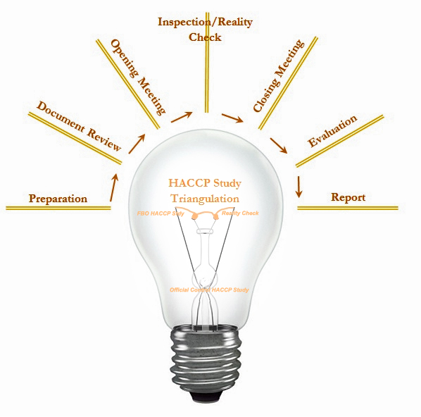

It should also be emphasised that the individual steps of HACCP are not the discrete focus during any of the aforementioned inspection stages; rather each stage of the inspection should address each relevant HACCP step as appropriate. It is anticipated that as the inspection progresses in any given establishment, the officer’s focus may naturally shift from an emphasis upon validation towards one on verification. The inspection process for all six stages is completed when all aspects of the FSMS have been verified and the aide memoir has been completed, with the appropriate objective evidence recorded.

3.2 Scope of the Inspection

Defining the scope of the inspection is a key activity and will ensure that the inspection is a rigorous systematic process, applying the aims and objectives of the inspection appropriately to the circumstances of the individual food business. The officer will need to take into account the factors listed below and adjust the scope accordingly. For example, if at the document review stage it is established that there are shortcomings with the validation of the FSMS, then it is appropriate that validation should become the principle part of the inspection.

Whether a full or partial assessment is carried out will depend upon the original purpose of the inspection. For example, a partial inspection (or some other intervention) might be appropriate where it is related to a particular incident or issue and is for investigatory purposes, or for closing out non-compliances.

Accordingly, defining the scope of the inspection will assist in planning the inspection.
The following is a non-exhaustive list of the factors that will influence the scope of verification:-

- Whether it is an initial assessment or follow-up;

- Whether it is a full inspection or another type of intervention specified within the Food Law Code of Practice;

- The nature and complexity of the operation, i.e. the type of products(e.g. RTE which require more attention based on risk than non-RTE) and processes, particularly the food science and technology used by the business;

- The number of HACCP studies to be assessed;

- The nature of prerequisite programmes;

- The volume of production/throughput/turnover;

- The level of in-house expertise and adequacy of resources available to the HACCP team;

- The number of employees

- The validation status of the FSMS;

- The nature of the Food Safety Management System, e.g. ISO 22000/ISO9000/BRC/SALSA;

- The results of previous assessments; and

- The population at risk

3.3 Planning & Managing the Inspection Process

Manufacturer FSMSs are often highly complex. Accordingly, the inspection needs to be planned systematically – in cognisance of the amount of time required. The extent of the FSMS must be appraised and the number of FBO’s HACCP Studies, CCPs and prerequisite programmes determined.

One simple technique for planning such an inspection is the use of a ‘Concept-Map. This is a useful method of mapping out the broad shape of the FSMS and for identifying the most critical elements of the FSMS, relating different elements of the FSMS and helping when planning audit trails.

Another related technique is to break the inspection down into manageable elements which are the subject of systematic focus, i.e. a ‘Bite-Sized-Chunks’ approach.

This has the benefit of allowing the officer to focus on a discreet number of areas, thereby gaining a better understanding of the documentation/processes etc. under review. This approach also allows officers to consider the nature of each establishment individually.

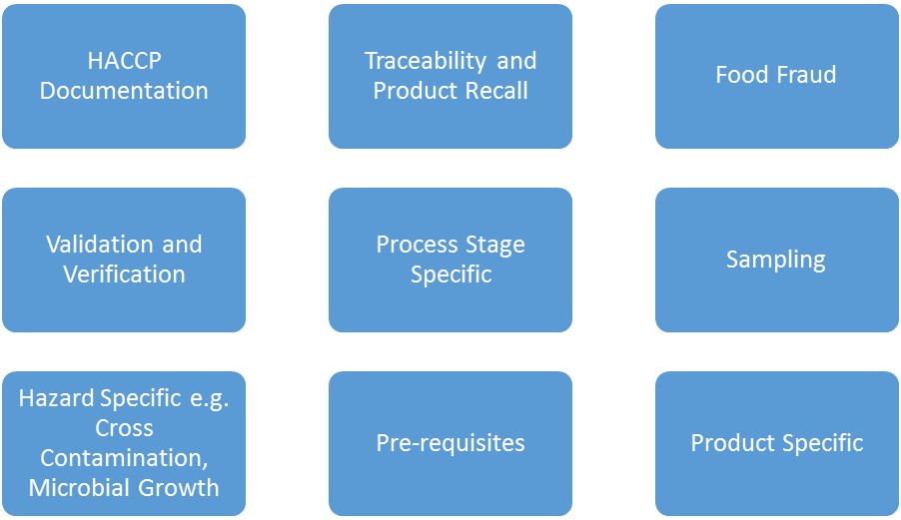

Figure 8 - Examples of Focused topics for the Bite Sized Chunks Approach

The bite-sized chunks approach can also help simplify the complexity of the manufacturing inspection which may otherwise appear overwhelming. It can be used together with concept mapping to identify critical connections of associated parts of the FSMS, for verification purposes.

Consequently, each stage of the FBO’s own HACCP Study and other elements of the FSMP such as product disposition control, product recall, cleaning and disinfection and pest control may become the subject of separate focus. The aide memoir may be divided into the elements under study and the objective evidence supporting Official Control Verification may be gathered and appended accordingly.

This approach can be applied flexibly throughout the entire inspection process, during the document review and the Reality Check phases, for example. This may be applied during the course of one visit e.g. one officer focusing on Traceability and Product Recall, while another may be carrying out an audit of the production of a specific product.

Ultimately, however, the officer must retain a sufficiently wide focus in order to be able to draw any critical inferences linking different elements of the FSMS.

Case Study 14 – Managing the Inspection and Gathering Objective Evidence.

An Officer inspecting a large manufacturer of various styles of unpasteurised cheese begins to plan the inspection by first allocating sufficient time to conduct an inspection according to these principles within the scope of the inspection.

The officer develops a systematic inspection plan which overlaps with the document review stage and recognises the complexity of the task of verifying a FSMS in such a context. The inspection plan is designed to comprehensively apply the principles referred to above – thus utilising the appropriate aide memoirs. The officer determines the extent of the FSMS and, in particular, the number of FBO’s HACCP studies to be verified as well as any changes to the FSMS since the last inspection.

The inspecting officer uses ' the ‘Bite-Size Chunks technique’ to maintain focus and to remain on track. This approach enables verification of each stage of the FBO’s own HACCP study to be carried out as a separate ‘sub-study’. Stage 6, for example, is verified by separating out the aide memoir into the relevant elements and cross referencing these to the FBO’s original work i.e. Hazard Listing and Hazard Analysis, original HACCP worksheets and minutes of the HACCP team meetings etc. These are all appended and/or referenced to the aide memoir in the appropriate places. ‘Concept-Maps’ are used to relate different parts of the FSMS, to plan the ‘Sub-Studies’ and to plan audit trails.

Each subsequent stage of the FBO’s own HACCP Study and other elements of the FBO’s FSMS are treated in the same systematic manner.

The aide memoir is updated as the relevant objective evidence is obtained at any stage of the inspection where it is appropriate to do so. The completed aide memoir is re-assembled at the end of the inspection with all the objective evidence attached or referenced.

The technique is more widely amenable to application to most elements within the FSMSs.

3.4 The Use of Aide Memoirs and Checklists

It is strongly recommended that a suitable aide-memoir or checklist be used in order to enable a systematic and objective approach to verification. It also directs the inspection activities within the scope of the inspection.

The model forms in Annex F and detailed in Table 3 below have been designed to reflect the inspection processes and tools in this guidance. Where alternative forms are used, these should be sufficient to demonstrate that the FSMS has been verified.

Document | Intended Purpose
Pre-inspection Documentation Schedule | To be issued at Inspection Stage 1 – Preparation for the Inspection to ensure that the officer has sufficient up to date information to allow for effective business profiling and FSMS review.
Business Information and Profile Form | For use during Inspection Stage 1 – Preparation for the Inspection to familiarise the officer with the establishment, products and hazards. The accuracy of the information should be confirmed during Stage 2 – Opening Meeting.
HACCP Assessment Checklist | For use during Inspection Stage 1 – Preparation for the Inspection to record the officers assessment of the documented FSMS. The officer may require additional information during Stage 2 – Opening Meeting and Stage 3 – Main Inspection to complete this aspect of the verification.
Reality Check Inspection Form | For use during Inspection 3 – Main Inspection to record objective evidence of compliance or non-compliance with the FSMS/OC HACCP study
Inspection Aide Memoir | For use during Inspection Stages 2-4 to record objective evidence of compliance or non-compliance with legal requirements (including certain aspects of HACCP)
Structured Aide Memoir for Step 6 | For use to assist with hazard identification, mapping and causation at any point during the inspection as necessary.
Table 3 - Model Checklists/Aide-memoir

3.4.1 Gathering Objective Evidence & Completing the Aide Memoir

Gathering objective evidence underpinning verification of both the positive and negative aspects of a complex FSMP can be laborious. One approach is to utilise the FBO’s own FSMS as objective evidence. According to this approach the FBO is asked to provide the appropriate elements of the FSMS. These may be referenced within and appended to the aide memoir appropriately.

3.5 INSPECTION STAGE 1 – PREPARATION FOR THE INSPECTION – HACCP STEPS 1 - 12

There are four main parts to this section, which are as follows:

- Business Profiling

- File/ Document Review - Overview of the FSMS and Prerequisites

- Verification of hazard analysis and control measures

- Evaluation of the validation process

3.5.1 Business Profiling

It is considered to be essential that the inspection process commences with a general profiling to include:

- Check of broad business profile and risk profile:

- Identification of the general food safety hazards; and

- Assessment of the general food safety risks associated with the business.

- Overview of the FSMS

These considerations should begin at the preparatory phase and will help to identify those areas of the operation which might require more or less attention during the subsequent inspection phases.

3.5.2 File/Document Review – HACCP Steps 1 - 12

Inspectors should be prepared to supplement their understanding by undertaking additional research in order to apprise themselves of relevant information that might not be held within the business file or database. For example, food hazards associated with the food products and processes and experience of these hazards in the past.

It is essential that the inspector acquires a sound working knowledge of the FSMS and its validation status – prior to the inspection. It is strongly recommended that current FSMS information relating to approved establishments is retained in the premises file.

Ideally, the Competent Authority should be provided with updates and controlled amendments to the FSMS by the business.

The file/document review process – which should be conducted before the inspection – constitutes a vital part of the overall inspection, serving to establish a broad risk profile of the business, to prepare and inform the inspector.

It is essential; therefore, that sufficient time is devoted to the file/document review and research, commensurate with the risk and/or complexity and size of the food business operation.

The officer should review and become familiar with product descriptions, including the vital product safety predicates, in order that he/she is later able to verify the FSMS in relation to these underpinning descriptions.

3.5.3 Verification of the Hazard Analysis

Accurate verification of the hazard analysis is vital to the aims and objectives of the inspection.

Effective FSMSs are founded upon accurate identification of the relevant hazards. Thus, if this vital early step within an FSMS is incorrect, a hazard or hazards can remain out of control throughout the entire FSMS. This often occurs because a relevant hazard has been overlooked or discarded in error, during the hazard analysis process. Where this has happened, it also follows that necessary control measures will be omitted.

These errors can be compounded by the inclusion of irrelevant hazards. In that case irrelevant (and sometimes expensive) ‘measures’ intended to control a non-existent hazard, can be put in place, only serving to distract the business from the real hazard.

Officers should be aware of the problems associated with generic groupings of hazards – such as ‘microbiological, chemical and physical’ etc. Bacteria for example have different physiological growth requirements which in turn mean that they are opportunistic contaminants under differing conditions. Therefore, frequently species specific control measures are required to control them. Officers should be prepared to undertake the appropriate research.

Allergens and additives are considered as types of chemical hazards.

Hazard Analysis is a skill in which Officers must be competent. They should, therefore, research the history of the safety of the product (or like products) and, consequently, apply systematic hazard analysis to the FSMS. Part 4 describes a basis for systematic scientific hazard analysis.

The officers should be prepared to access relevant literature in order to obtain information on hazards associated with the products and to learn about key specific food science and technology aspects. In effect, preparation involves more than looking at the file and the FSMS. Verifying the hazard analysis often requires considerable research and experience.

3.5.3.1 Verification of the Hazard Analysis – HACCP Steps 5 - 6

There are three key considerations when verifying the Hazard Analysis:

Adequacy - the adequacy of the hazard analysis, in particular whether all significant hazards have been identified, ensuring that this has been undertaken for all products and processes within the scope of the inspection needs to be considered.

Assessment - in assessing the analysis of hazards, the officer may require access to supporting evidence from the FBO at this stage. This may take the form of, for example:

- records of the hazard analysis process;

- records of validation;

- end product testing results;

- history of the safety of the product;

- generic plans;

- relevant and appropriate predictive models where they have been used.

Competency - an important part of the process will be gauging the competency of the people responsible for the FSMS/HACCP study – in particular, those conducting the hazard analysis. One method of doing this is for the inspector to take sections of the process flow diagram, preferably a high-risk section and, without reference to the HACCP control chart, carry out desktop hazard analyses using their own expert knowledge and reference material. At this stage, the inspector may also consider the following:

- Have significant food safety hazards been included or have any been omitted?;

- Have hazards and control measures been precisely defined or are they vague and general?;

- Has the hazard analysis been carried out systematically?; and

- Have control measures been identified for each specific hazard, are they realistic and scientifically valid?

Consideration should also be given at this stage as to whether:

- Control measures eliminate or reduce identified significant hazards to acceptable levels (HACCP Steps 7 and 8);

- Monitoring of CCP’s is sufficient to identify any loss of control (HACCP Step 9);

- Identified corrective actions will prevent unsafe food from entering the food chain (HACCP Step 10);

- Verification procedures are adequate and effective (HACCP Step 11).

3.5.4 Evaluation of the validation process

Evaluation of the validation process is covered in detail in Part 4 of this guidance.

INSPECTION STAGE 2 – THE OPENING MEETING

3.6 Opening Meeting

An opening meeting with the FBO should, where practicable, be carried out prior to undertaking the inspection.

It is essential that:

- the purpose of the meeting is clarified; and

- the method and approach being taken by the inspector is explained.

The precise nature of the opening meeting should be determined on a case-by-case basis – at the discretion of the officer – taking into consideration the conditions found at the establishment that day.

The opening meeting need not be restricted to an office environment. While an office location is conducive to perusal of FSMS documents, the officer should familiarise him/herself with the operation at this phase – especially when visiting the premises for the first time.

It is recommended that the officer devotes adequate time to “walking the line”, i.e. systematically following the process flows throughout the establishment to inform and clarify in overview, many aspects of the business operation and the FSMS. This process will assist in determining focal points for the subsequent inspection.

In particular, where considered appropriate, it is recommended that the officer gain immediate access to food handling areas (especially high-risk areas) to allow some physical observations to be carried out at this early stage of the inspection.

3.6.1 Key Issues to be covered

Accepting the need for flexibility, it is suggested that there are three overarching principle actions:

- Confirm the accuracy of the business/risk profile already held on file;

- Identify and account for changes in the business/risk profile; and

- Clarify any matters arising during Inspection Stage 1 – Preparation for the Inspection

This list is not exhaustive.

The opening meeting would normally include initial reference, discussions and questioning on the suitability and implementation of the FSMS. However, assessment of the implementation of control measures and monitoring would also require a viewing of some actual food production and storage areas – which would normally be undertaken later in the inspection. At this stage, any additional documentation required for the inspection could also be requested and examined.

3.6.2 Assessment of Validation

It is recommended that a key aspect of Inspection Phase 2 – Opening Meeting, is the assessment of both verification and validation of the FSMS.

3.6.3 Food Related Crime

Throughout the inspection process, the officer should be alert to any evidence of food related crime. This will assist to identify dishonest acts or omissions relating to the production and sale of food, along with potential serious or complex fraud or serious and dishonest regulatory non-compliance.

A key consideration is whether the FBO can account for the source, presence, use and disposition of all ingredients. The mass balance tool referred to later in this guidance can assist the officer in verifying this.

The officer should also consider any clear vulnerabilities which may expose the business to food related crime from elsewhere in the food supply chain.

Potential evidence of Economically Motivated Adulteration or Fraud:

- Presence of ingredients on site or detailed on invoices which cannot be accounted for in recipes etc.
- Quantities of ingredients on site which do not correspond with the scale of production.
- Quantities of ingredients that do not comply with approval conditions e.g. loading rates for depuration tanks
- Quantities of inputs, outputs and waste which do not reconcile

Potential evidence of sourcing of Illegal Ingredients, in particular POAO:

- Failure to be able to verify supplier information for an ingredient.
- Sourcing ingredients from individuals or groups known or suspected to be involved in the supply or facilitation of illegal ingredients.

Examples of vulnerabilities to Food Fraud:

- Product security e.g. on site, during transport and the finished product itself. Is there uncontrolled access to the product, is the final product packaging tamper evident?
- Failure to obtain detailed invoices for ingredients, particularly POAO which should comply with EC Regulation 931/2011

INSPECTION STAGE 3 – THE MAIN INSPECTION
3.7 The Main Inspection

The purpose of the main or ‘on-site’ inspection is to verify that procedures and practices described in the FSMS and the prerequisites are adequate to ensure food safety and are actually implemented within the context of production and processing.

The scope of the inspection has been determined during Inspection Stage 1 – Preparing for the Inspection. However, the identified scope may change depending upon the findings of the opening meeting. The scope of the assessment should also be changed during the assessment if major deficiencies are found. An audit trail might, for example, lead to an issue that requires immediate attention. This would constitute a ‘break out’ from the defined scope.

The inspection will consist of a combination of activities including:

- A review of the relevant documentation relating to the FSMS (including prerequisites) and an assessment of their adequacy and accuracy;

- A physical examination of the processes, practices and records by means of observation, measurement(e.g. checking the temperature of the products or sterilisers) or interview – to assess whether the actual operation in practice is valid in terms of food safety and complies with the documented procedures.

In practice, the early stages of the Main Inspection will naturally overlap with the Opening Meeting.

Officers may find it appropriate to address HACCP Steps 2, 3, 6, 7, 8 and 11 immediately following the opening meeting, where access to the office environment is conducive to the extensive paperwork references that will be required. Key areas of evaluation include an assessment of the following:

- Description of the products and the identification of their intended use;

- Detail of hazard identification and analysis;

- Validation of the control measures and critical limits;

- Determination of the CCPs;

- Validation of monitoring procedures;

- Whether corrective actions are being undertaken;

- Whether the relevant record keeping is being undertaken;

- Whether the records confirming controls are being maintained.

3.7.1 Assessing Key HACCP Steps

HACCP Steps 1, 2, 3, 6, 7, 8 and 11 are critical to any FSMS based on HACCP Principles, yet they are often overlooked by businesses. Errors in their application would undermine the FSMS/HACCP Plan however carefully it was implemented.

The officer must be prepared to study documents such as HACCP worksheets and minutes of HACCP team meetings, where available.

Perusal of these will enable the officer to drill down into the FSMS to identify objective evidence, e.g. the accuracy of hazard identification and analysis, scientific validity of control measures and critical limits and the accuracy of CCP identification.

Inspectors must also actively challenge the thinking underpinning the FSMS – particularly assumptions/rules of thumb - by cross-referencing observations against their own knowledge, experience or research. These tasks are critical and must be allocated an adequate amount of time.

3.7.3 Verifying HACCP Steps 4 and 5 – The Process Flow Diagram.

(Indicated Inspection Stages: Opening Meeting & Main Inspection/Reality Check)

The accuracy of the process flow diagram must be verified.

3.7.4 Verifying the Control of Product Disposition

Product disposition management is closely allied to considerations of process flow. It relates to control of the position of all components of the final product and the final product itself. The FBO must be in control of the traceability of all product components throughout the manufacturing process. Tracking also extends to being able to account for the original provenance of all the components used in final product. Using these FSMS components, the FBO should be able to account for the disposition of products, packaging, non-conforming product and waste product at all times. This is achieved by the dual processes of reactive tracking and proactive tracing of products and ingredients. The latter process is essential to eliminate fraudulent substitution of ingredients. Figure 9 below summarises these concepts.

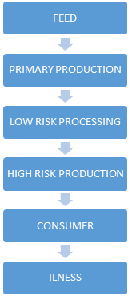
T R A C E A B I L I T Y
T R A C K I N G

Figure 9 - The Concepts of Tracing and Tracking

The control of the disposition of ingredients, products, waste products and packaging is essential to a FSMS. The FSMS cannot operate if disposition is not known and is not under control. In the absence of disposition control, products and packaging cannot be verified as being subject to CCPs nor can they be adequately protected from contamination. Similarly, without disposition control, waste products could be recycled back into the human food chain and fraudulent adulteration and substitution may not be prevented.

Product Disposition Control embodies a number of inter-relating elements as follows: -

- Process management;

- Master Manufacturing instructions;

- Provenance/ Supplier Approval;

- Ingredients specification;

- Traceability – Including systematic, comprehensive and accurate internal traceability;

- Production Coding;

- Lot Marking;

- Labelling;

- Approval Coding;

- Control of Non–Conforming product, ingredients and packaging, Including Re-Work procedures; and

- Waste Control

Similarly, verification must also be applied to waste and non-conforming products and packaging. Waste products must be prevented from being returned into the process flows.

It is suggested that inspectors use the Business Profile form to identify Competent Authorities responsible for Official Controls in the supplying establishments in order that tracing can be undertaken in a continuous, joined-up manner. This practice may also assist in the identification of Food Fraud.

3.7.5 A Mass Balance Approach

Mass balance is a reconciliation exercise, relating the quantity of products and ingredients entering the establishment with those leaving as product placed onto the market or as waste.

One suggested approach is to select a random sample of finished high risk product and, using the lot mark as a reference, systematically track the products backward from the end of the process flow diagram, throughout the entire process flows (including all ingredient and packaging process flows) eventually culminating in the receipt of all ingredients and packaging. This process should be conducted whilst auditing against Process Management procedures, approved supplier and product specification etc.

Case Study 15 – Mass Balance

During the main inspection of a smoked salmon manufacturer, the inspecting officer randomly samples three days of production and requests the following:

Records for the purchase of all ingredients
Relevant production records
Records of finished product sales
Records of waste products

Where these to not reconcile to the satisfaction of the officer, further enquiries and audit trails may be necessary.

In practice, it is unlikely that exact reconciliation will be demonstrated, therefore the officer should use their professional judgement to determine whether further investigation is required.

The process of verification must also focus upon samples of re-worked products. (These will probably have to be selected from archival records.) Such products must be prevented from being returned into the main process flow(s).

If this is successful, all products should be able to be tracked back to the raw ingredients and packaging. The input quantities and output quantities should agree with the master manufacturing instructions (with wastage subtracted).

Verification of disposition control is completed when all samples have been found to conform to the FSMS.

3.7.6 Verification – HACCP Steps 4 to 12

At each step in the process flow, the officer should continue to conduct his/her own HACCP Study, comparing and cross-referencing that against the FSMS as it is written down and against how the business is actually operating and performing in practice. (See also Part 4 – General Guidelines for Conducting an Official Control HACCP Study)

Key areas of consideration include confirmation of the following:

- The flow diagram is consistent with the way the business is actually operating;

- The hazard identification and the hazard analysis are accurate within the environment of the operation. Part 4 provides a structured approach to hazard identification and analysis;

- Control measures are being applied;

- The control measures in practice are capable of eliminating the hazard or reducing it to an acceptable level;

- All steps that are critical have been identified as such;

- CCPs have been applied in practice;

- Critical limits are in operation;

- Monitoring is being undertaken;

- Corrective actions are being undertaken; and

- Relevant documents are being referred to and records are being maintained.
Overall, the officer should be prepared to triangulate all elements of the FSMS to the operation in practice and to the Official Control HACCP Study (see Part 2), in order to confirm the objective that the operation in practice is safe or unsafe. The officer should observe practices in reality and make his/her own measurements as required.

It is essential that staff working at CCPs are interviewed in order to verify their understanding of the hazards they are controlling, that they can competently implement the control measures stated in the FSMS and that they can competently undertake monitoring, corrective actions and record keeping. Critically, officers will need to cross reference their findings in terms of observations, assessments of understanding and assessments of competence to their own HACCP Study and to the FSMS.

3.7.7 Corrective Actions - HACCP Step 10

Any stage of the inspection, but particularly the main inspection, will identify non-conformances. The key to verifying a live system is the pursuit of audit trails that verify that the requisite corrective actions are being undertaken.
INSPECTION STAGE 4 – THE CLOSING MEETING
3.8 The Closing Meeting

A closing meeting should be held with the FBO and/or their representative to discuss and consider the findings. It is suggested that the personnel responsible for the development and verification of the FSMS are also in attendance.

The officer should represent the findings on the verification of the FSMS, i.e. Verification of the FSMS in terms of agreement between the Official Control HCCP Study and the Reality Check. This should include the following points, although not exclusively so: -

- The validation status of the FSMS.

- Confirmation and description of any hazards identified by the Official Control HACCP study that are not in agreement with the FBO’s FSMS.

- Confirmation of any:

hazards that are not subject to control measures.

failure to define critical control points and validated control measures

failure to implement critical controls

failure to define validated critical limits

failure to define monitoring procedures at CCPs

failure to undertake monitoring at CCPs

failure to define corrective actions at CCPs

failure to document the FSMS as defined by the FBO or as required by law.

failure of verification

- Confirmation of any contraventions of relevant legislation

- The Approval status of the establishment post-inspection

- Confirmation and explanation of any proposed enforcement action, by reference to the Authority’s Enforcement Policy

- Discussion on the timescale for compliance.

- Recommendations of best practice
There should be clear differentiation between measures required to comply with legal requirements and recommendations of best practice.

The officer should emphasise any non-compliance found and the associated food safety implications. The non-compliance issues should be prioritised in order of public health significance, so far as is reasonably practicable. (See the Risk Assessment Quadrant in Inspection Stage 5 – Evaluation of Observations)

A corrective action plan specifying the remedial actions necessary and an appropriate timeline for completion should be agreed with the FBO.

The closing meeting should also be used to foster the partnership between the officer and FBO by discussing possible improvements to the process and documentation. This is where the officer’s training and experience play a central role in improving the systems, both in practice and in theory. If improvements are agreed upon, they should be included in the inspection report for future reference and should be explicit in their recommendation format.

3.8.1 Verifying Product Recall

Product recall flows from disposition control. FBOs must also be able to implement an effective product recall in order that the consumer is safeguarded against a hazard that has not been eliminated nor reduced to an acceptable level. Effective recalls are based upon robust disposition control. Applying effective disposition control, an FBO will be able to establish the following:-

- The quantitative and qualitative aspects of a batch that contains a hazard; and

- The distribution of the batch that contains the hazard; and

- How much of the batch has been recalled or quarantined; and

- How much of the batch contains the hazard remains i.e. how much is the consumer still exposed to?

Similarly it is critical that this is verified. One suggested approach is to select a batch as identified by its lot-mark and require the FBO to simulate a product recall supplying all of the objective evidence of distribution of the product and tracking the product retrospectively through the process flow to the point of provenance. Relevant processing records should be obtained in order to verify that control measures have been applied in relation to the batch.

The FBO needs to obtain evidence that the business can achieve effective product recall within a timeframe that minimises exposes of the public to the hazard and allows for the FSS to instigate a Food Alert and/or a press release as is required.

Case Study 16 – Product Recall (Reverse Trace) – Distillery

Prior to the inspection of a Distillery producing Scotch Whisky and gin, the inspecting officer visits a retail establishment known to stock product produced on site and records details of one bottle offered for sale. Following the opening meeting of the inspection, the officer provides the FBO with the product details and requests a product recall be simulated for that batch of product.

The FBO produces the following documentation:

- Product Recall Procedure
- Purchase records for the ingredients
- Internal traceability and production records
- Stock control records identifying the quantities distributed and remaining in storage
- Customer contact list

The information provided demonstrates to the officer that the business can identify the quantity of product to be recalled, the location and recipients of the product and that they have means to contact customers within an acceptable timescale to effect the recall.

Case Study 17 – Product Recall (Forward Trace) – Mussels

An officer is carrying out an inspection of a dispatch centre for Live Bivalve Molluscs. The business purchase mussels from several harvesting areas and dispatch these to local restaurants as well as exporting to Europe and Asia. During the inspection the officer proposes the following scenario:

A harvesting area for Mussels has been closed following detection of high PSP levels. The failed sample was taken on 8th November (three days before the inspection). The previous sample taken on 1st November was satisfactory. Can the business identify the product which requires to be recalled and implement an effective recall? Incoming records indicate that the business received Mussels from the closed site on 2nd , 4th, 6th and 7th November.

Scenario 1: The FBO produces:
- Registration documents for all incoming products and dispatch records for outgoing product. However, there is no internal traceability to demonstrate which incoming products were supplied to which customers.
- PSP toxin testing results, the most recent being for 25th October.
The FBO cannot demonstrate that any products received since 2nd November are not affected and therefore would require to recall all mussels supplied since 2nd November.

Scenario 2: The FBO produces:
- Registration documents for all incoming products.
- Dispatch records which contain a traceability code to identify which batch of product was supplied to each customer.
- PSP toxin testing results, the most recent being for 25th October.
The FBO can demonstrate that some customers have been supplied with product unaffected by the recall, therefore limiting the recall to customers receiving mussels from the closed harvesting area since 2nd November.

In the above scenario’s the FBO will be required to demonstrate that they can effectively identify and contact immediate customers to effect the product recall.

Scenario 3: The FBO produces:
- Registration documents for all incoming products.
- Dispatch records which contain a traceability code to identify which batch of product was supplied to each customer.
- PSP toxin testing results for each incoming batch of product. These results are all negative for PSP and the results are stored in the test machine for officers to view. (The correct use of the machine will be verified as part of the inspection process)
The FBO can demonstrate that all incoming batches of product are within acceptable limits for PSP and therefore no product requires to be recalled.

INSPECTION STAGE 5 – EVALUATION OF OBSERVATIONS

3.9 Evaluation of Observations

As stated in Part 1, this document does not seek to advise the officer upon the enforcement approach which is appropriate in any given situation. Verification findings will vary in terms of risk to food safety. The semi-quantitative risk assessment model shown in Figure 10 demonstrates a method of evaluating the risk associated with an uncontrolled hazard.

Figure 10

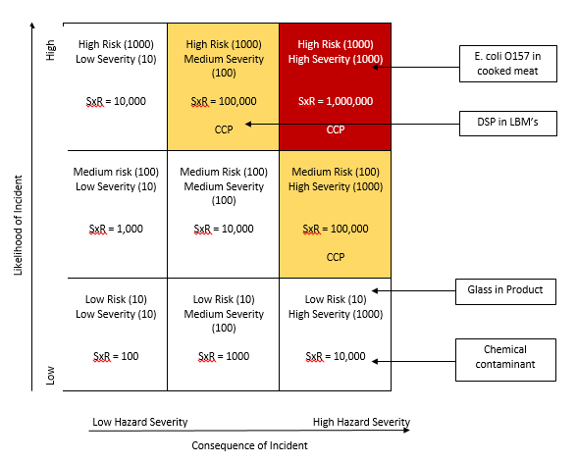

It is obvious that the greater the risk to food safety the more urgent any corrective action should be. This process of evaluation may, therefore, inform enforcement decisions.

3.9.1 Enforcement

It is recommended that considerations relating solely to enforcement are separated from the active inspection process itself. Consequently, these are not addressed within the text as the range of enforcement options available to officers is well established and subject to existing guidance.

According to this approach, an uncontrolled hazard should be considered as such, without being interpreted or discussed in the context of legislative non-compliance. (This is not to say that the inspection process does not include an aspect of evaluation. In effect, this document does not seek to influence the enforcement approach employed by Competent Authorities. This is consistent with WHO/FAO guidance and enables Local Authorities to implement a systematic, science-based inspection methodology, within the context of their own enforcement policy.

Furthermore, the document does not seek to provide guidance upon the evaluation of inspection findings nor upon the content and format of the subsequent inspection report. These matters are already covered in the Food Law Code of Practice and Practice Guidance.

INSPECTION STAGE 6 – INSPECTION REPORT

3.10 Inspection Report

The Food Law Code of Practice provides information upon the minimum standard for reporting upon food safety inspections. This document does not, therefore, seek to do so.

However, it should be emphasised that the content of the report should be relayed to the FBO at the closing meeting, the timescales for corrective actions agreed and stated in the report and there should be clear definition between legal requirements and recommendations of best practice.

PART 4

GENERAL GUIDELINES FOR CONDUCTING AN OFFICIAL CONTROL HACCP STUDY

4.1 Introduction

Part 4 of this document represents general guidelines for the conduct of the Official Control HACCP study. The purpose of the Official Control HACCP Study is to provide the standard with which the FBO’s FSMS is compared and contrasted - through a process of Gap Analysis. The intention is to gauge or measure the fitness for purpose of the FBO’s FSMS in terms of food safety.

The creation of this external reference point is critical to the purpose of this document and it is only through the process of Gap Analysis between the FBO’s FSMS and the Official Control HACCP Study that the validity of the said FSMS can be verified. Only then can the question ‘does the FBO say that he or she intends to do the right things?’ be answered.

The guidance contained in Part 4 represents a methodology for conducting a HACCP study from the standpoint of a food law enforcement officer. This involves the use of algorithms which are intended to represent the officer’s thinking - although it is not intended that the officer’s thought process should be restricted unnecessarily, rather that professional judgement is informed and guided by the steps of a HACCP study. The table below summarises the Steps and the Principles of a HACCP Study.

Verifying Steps 1 to 12 - The steps of the Official Control HACCP study are as follows:

HACCP Step | Task | HACCP Principle
Step 1 | Assemble HACCP Team
Step 2 | Describe Product
Step 3 | Identify Intended Use
Step 4 | Construct Flow Diagram
Step 5 | Confirm Flow Diagram
Step 6 | List all potential hazards;  Conduct a hazard analysis;  Consider control measures | Principle 1
Step 7 | Determine CCPs | Principle 2
Step 8 | Establish Critical Limits | Principle 3
Step 9 | Establish Monitoring | Principle 4
Step 10 | Establish Corrective Actions | Principle 5
Step 11 | Establish Validation, Verification and Review | Principle 6
Step 12 | Establish Documentation and Records | Principle 7

Table 4 – Codex HACCP Steps

4.2 Scope

The scope of the Official Control HACCP Study is comprehensive, encompassing the entire FSMS, including;

- the management of generic food safety hazards within the pre-requisites programmes,
- the management of traceability, disposition, lot marking and non-conforming product
- the management of food specific hazards within the HACCP Control Chart, and
- reactive elements such as product recall etc.’

Figure 11 below represents the scope of the Official Control HACCP Study and, ideally, that of the FBO’s FSMS

Figure 11 – Scope of Official Control HACCP Study

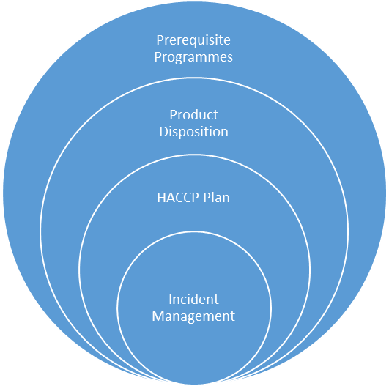
Generic Food Hazards
Process control, Traceability, provenance, Lot Marking etc.
Food Specific Hazards
Recall, Rework etc.

4.3 Verifying HACCP Step 1 – Assembling the ‘HACCP Team’

Relevant Inspection Stages: Preparation and Opening Meeting

Two key areas of verification in terms of the HACCP team relate to commitment of the FBO and the competency of the team.

Without FBO commitment, the FSMS is significantly undermined. The commitment of the FBO is often considered to be an essential prerequisite in its own right.

The ‘HACCP team’ must also be competent. Frequently the team requires a multidisciplinary approach comprising specific knowledge and expertise appropriate to the product, the process and the processing environment.

It is acknowledge that the terms ‘HACCP team’ and ‘multidisciplinary approach’ reflect an idealised situation – one that is frequently not reflected by reality, particularly within many SMEs. However, these principles remain valid even where there is a degree of scaling applied in terms of the size of the HACCP team in proportion to the size of the business. In effect, the principle of competency must be undermined by considerations of resources.

Figure 12 below represents the process, which may be followed when verifying the ‘HACCP Team’.

Figure 12 – Validation of the HACCP Team

Is there a written statement of the FBO’s Commitment to the FSMS?
(i.e. a Food Safety Policy)
No
Consider Audit Trail

Yes
Is there a written statement of the FBO’s provision of resourcing of the FSMS?
No
Consider Audit Trail

Yes

No
Is there a designated food safety ‘champion’ or ‘lead’ within the food business?
Consider Audit Trail

Yes
Is the Food Safety Management ‘Team’ comprised of relevant disciplines/roles?
No
Consider Revision

Yes

No
Do QA Management and Production Management have equal authority?
Consider Revision

Yes

HACCP ‘Team’ Potentially Validated

4.4 Verifying HACCP Steps 2 and 3 – Description of the products and their intended use

Relevant Inspection Stages: Preparation

The verification of product descriptions is essential as these descriptions represent the foundation of the FSMS. In effect, the process of construction of the FSMS is informed by the product descriptions and the system must accurately reflect these. The two must be congruent if the FSMS is to be coherent.

Figure 13 below represents the process which may be followed when verifying the description of the product and the definition of intended use. This needs to be supplemented by knowledge of the relevant foods hazards and the food science and technology involved.

Figure 13 – Verifying the Product Description

No
Has the product been described in general terms?
Consider Review

Yes
Has the product composition been described e.g. ingredients, protein content, P.O.A.O., allergenic content etc?
No
Consider Review

Yes

No
Have product microcidal treatments been prescribed, e.g. thermal processing, ultra-violet light etc?
Consider Review

Yes

No
Have product intrinsic factors (particularly those that extend shelf life) have been described e.g. pH, water activity, salt in aqueous phase, redox potential, preservatives?
Consider Review

Yes
Have the product extrinsic factors (particularly those that extend shelf life) been described e.g. vacuum packing, modified atmosphere packaging, storage conditions, shelf life etc?
No
Consider Review

Yes
Has the intended use been described, i.e. the manner of usage by the recipient including any further processing required to achieve food safety and consumption by vulnerable people e.g. paediatric, geriatric and the immune-compromised?
No
Consider Review

Yes

Potentially accurate and comprehensive
description in food safety terms

Product descriptions do not need to be extensive or complicated. Concise descriptions need contain only the information relevant to the description the product in food safety terms as in the following example:

Case Study 18 - Product Description

Hard Cheese Unpasteurised (Cheddar Style):

- A ‘cheddar style’ hard cheese, containing products of animal origin, i.e. bovine milk (which is a human allergen)
- Rendered safe for human consumption through an extended maturation process, in excess of 60 days, subject to the intrinsic factors of a_{w}, salt content and pH as validated against regulation (EC) 2073/2004 as amended,
- Intended as a ready to eat product;
- Non-shelf stable at ambient temperature, i.e. requiring chilled storage, with a shelf life of 90 days.
- No other particular end-user instructions.
- Allergenic declaration in terms of milk.
- Customer warning in terms of vulnerable groups, i.e. pregnant women and made with ‘raw milk’ declaration.

4.5 Verifying Step 11 - Verification Procedures

Relevant Inspection Stages: Preparation and Opening Meeting

4.5.1 Verifying Validation

Validation relates to proving the efficacy of the entire FSMS prior to production in terms of placing food on the market. The importance of validation of FSMSs has been emphasised in recent years, particularly in relation to the validation of control measures and the validation of critical limits.

FSMSs must be validated prior to food being produced. Validation is often, incorrectly, carried out after production has commenced – based upon post-production data. This should not, however, be accepted on safety grounds. The botulism outbreak associated with hazelnut yoghurt described in case study 1 illustrates the dangers of inadequate validation. Figure 14 below represents an algorithm which may be used to verify the Validity of the FSMS.

Figure 14 – Verifying Validation

No

Has the FSMS been signed by the FBO as Validated?
Pursue Audit
Trail

Yes
Does representative End Product Testing (EPT) validate overall FSMS capability with reference to objective standards and criteria, e.g. EC Regulations 853/2004 and 2073/2005, HPA, IFST etc?

No
Pursue Audit
Trail

Yes
Where the processes are novel, have process capability trials which validate the process been undertaken?
No
Pursue Audit
Trail

Yes
Are individual control measures and critical limits based upon statutory standards as required or does data support the validity of individual control measures and critical limits?
No
Pursue Audit
Trail

Yes

No
Have shelf-life trials validated the safety of the product at the end of the shelf-life?
Pursue Audit
Trail

Yes

Validation process potentially validated

4.5.2 The Difficulties of Verifying Validation

It is acknowledged that verifying validation, particularly in relation to control measures and particularly in relation to Critical limits is a specialist activity. Verifying validation is one area in particular where the inspector may require the assistance of specialist input.

4.5.3 Verifying Verification

The verification status of the FSMS itself requires verification during the early stages of the inspection process. Figure 15 below represents an algorithm, which may be used to verify the verification status of the FSMS.

This may be indicated by an assessment of the validation data, end product testing results, internal and external audit documentation as well as the frequency and thoroughness of all verification activities.

The inspector should consider whether changes or deficiencies in the HACCP plan, new emerging hazards, etc., are adequately addressed. The officer should also consider what actions are taken as a result of inadequacies in the FSMS (including its prerequisites) or any other non-conformity.

Figure 15
Application of HACCP Principles 1 to 7?

Preparation of HACCP Plan?

Validation of HACCP Plan
Improvements

Acceptance of Validated HACCP Plan

Implementation of HACCP Plan

Verification:

- Compliance with 7 HACCP Principles
- Existence of new data

Remedial Action
Remedial Action

4.6 Verifying HACCP Steps 4 and 5 – The Process Flow Diagram

Relevant Inspection Stages: Opening Meeting and Main Inspection

This is vital as deviation from the process flow is frequently the first sign that the actual operation is deviating from the FSMS itself, i.e. the FSMS is becoming invalid. Verification will also underpin understanding of whether the CCPs are correctly identified and also the potential for post process contamination.

Once the determination of validity had been made, the focus tends to shift towards verification, i.e. “are they doing what they say they say they are doing?” This involves the same HACCP principles, but with more focus on their practical application.

Verification of the accuracy of the process flow diagram is essential and integral to the Official Control HACCP study and to the process of cross-referencing with the FBO’s FSMS. Inaccuracy or error at this stage will ramify throughout the subsequent steps of the FBO’s HACCP study, possibly rendering them and the ensuing resultant FSMS invalid.

Verification is undertaken by a detailed ‘walk of the line’ and meticulous cross-referencing of the actual operating sequence to the process flow diagram. The inspector systematically and sequentially tracks the product(s) throughout the entire process flow(s); beginning at the point where raw materials are received and ending at the point where the finished product is packed or dispatched. Subsidiary processes flows, e.g. staff flows and waste flows may then be subsequently verified. Figure 16 below represents the systematic process of tracking the process flows

Figure 16 – Systematic/Sequential Tracking of the Process Flows

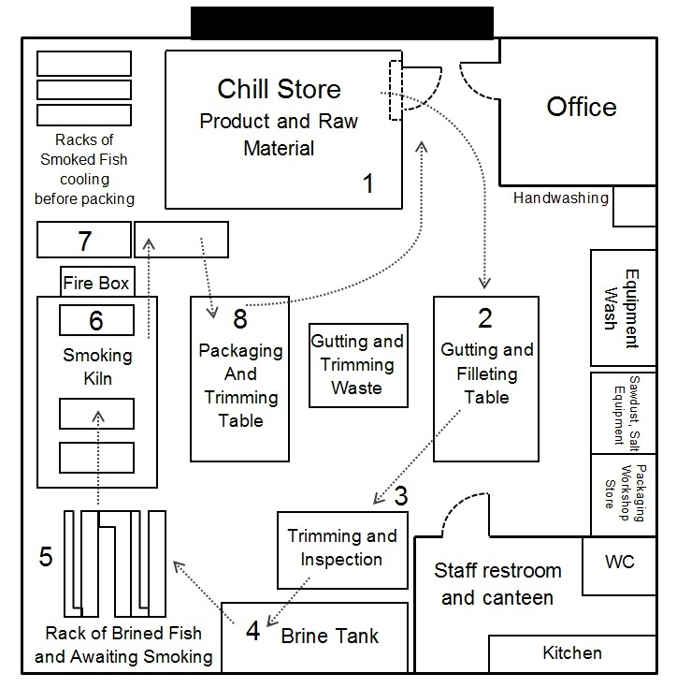

The Process Flow Diagram as the Framework for the Remainder of the Official Control HACCP Study

The Process Flow Diagram represents the essential framework for the FBO’s HACCP study as well as for the Official Control HACCP Study.

The remainder of the Official Control HACCP Study is undertaken using the verified Process Flow Diagram(s) as its framework. The inspector systematically and sequentially tracks the process/packaging/personnel and waste flows applying the following steps of the Official Control HACCP Study to each step and to the prerequisite programmes.
4.6.1 Introduction to Step 6 – Listing Potential Hazards, Conducting Hazard Analysis and Considering Control Measures

Step 6 presents perhaps the greatest challenge to the FBO and the officer during an inspection. If the potential hazards and their nature cannot be recognised and understood, the official control process will be compromised.

Despite this, reference to this process in the WHO Codex is quite abstract:

The HACCP team… … should next conduct a hazard analysis to identify, for the HACCP plan, which hazards are of such a nature that their elimination or reduction to acceptable levels is essential to the production of a safe food.

In conducting the hazard analysis, the following should, wherever possible, be included:

- The likely occurrence of hazards and the severity of their adverse effects;
- The qualitative and/or quantitative evaluation of the presence of hazards;
- Survival or multiplication of micro-organisms of concern;
- Production or persistence in foods of toxins, chemicals or physical agents and,
- Conditions leading to the above
- Consideration should be given to what control measures, if any exist, can be applied to each hazard.

WHO Codex 2003

Step 6 constitutes perhaps the most frequently misunderstood and misapplied element of any HACCP study. A simplistic requirement to produce process flow diagrams and apply very broad categories of hazards, such as biological, chemical and physical at each step is likely to lead to misunderstanding.

Manufacturing can be a highly complex operation, involving multiple product lines as well as numerous production, personnel, packaging and waste process flows. Many of these afford the opportunity for the introduction, multiplication and survival of food hazards. There is also the additional human factor which can lead to pressure to achieve just in time production for high-risk, short shelf-life products.

It can be a challenge to list the hazards at each step of a process flow diagram in a meaningful or consistent way. Although such terms and concepts as the source/cause/manifestation descriptors of hazards have become established within regular HACCP terminology, they may not be defined or practiced sufficiently. The mnemonics P.I.I.G.S. or P.I.I.M.S. are often used in this context:

P. | - Presence | P. | - Presence
I. | - Introduction (by cross contamination) | I. | - Introduction (by cross contamination)
I. | - Introduction (by direct contamination) | I. | - Introduction (by direct contamination)
G. | - Growth | M. | - Multiplication
S. | - Survival | S. | - Survival

However, if the underlying science is represented and Step 6 is then broken down into bite sized-chunks, reassembled and then practised as a skill expressed in simple terms, the process can be made easier to apply and the outcomes can be more successful.

This section of the document deals with the application of this methodology. Step 6 is first explained with a focus upon the microbiological hazards. This is addressed in terms of the underlying microbiology and epidemiology addressed in terms of a bite-sized-chunks treatment. Step 6 will also be considered in simple terms by considering the microbiology and the epidemiology in terms of a ‘4W’ approach i.e.:

- What are the hazards?
- Where and when do the hazards occur?
- Why are the hazards occurring i.e. what is their cause?
- What does the FBO need to do to eliminate the hazards or reduce them to an acceptable level?

The approach described here seeks to provide clarity in relation to WHO-Codex treatment of this issue and to help develop an inspector’s skill in applying what are fairly abstract concepts. Officers are provided with inspection tools in the form of a structured algorithm and a Step 6 Aide-Memoir which may be used at any point during the inspection.

This approach leads to the analysis of the linkages between the process being inspected and the actual causes of food borne disease as confirmed by microbiology and epidemiology. It is suggested that this can be a useful methodology when delivering effective official controls.

The Microbiological and Epidemiological Basis of Step 6

A literature review suggests that Step 6 had not previously been addressed in this way. However, the approach below is based upon a number of precedents:

- Bryan (WHO Codex (‘Epidemiological Contributory Factors concept’)) - 1992
- LACORS (Relevance approach to ‘Hazard Mapping’) 1993
- Structured Approach’ to Step 6 formulated by Mortimore and Wallace 1998
- ‘Hazard mapping’ – Food Law Code Practice Guidance Food Standard Scotland 2014 and antecedents (Note the terms ‘Hazard Mapping’ is not elaborated upon and must be inferred).

Thus, through the references back to the work of Bryan, the approach to Step 6 here is based upon the science of epidemiology – an approach aligned to Official Control Verification.

4.6.2 The Microbiological Dimension

Food-borne illness is a predictable natural process that has been described by science. This is represented by the Bacterial Growth Curve below.

Figure 17 – Bacterial Growth Curve

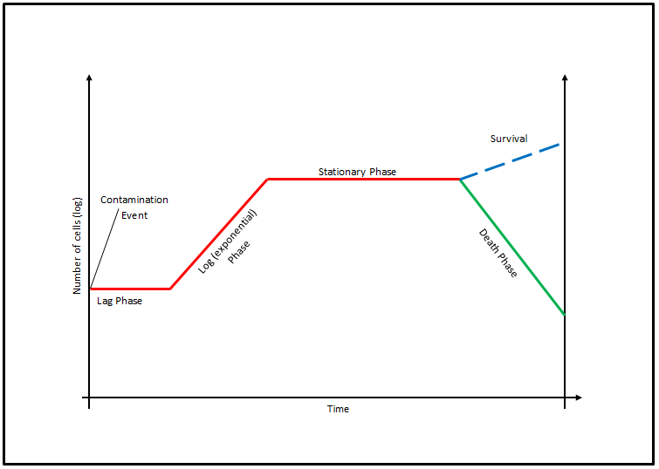

Microbiology confirms that the introduction of a bacterial pathogen by contamination to a suitable growth medium, may exceed an infective dose. Alternatively, suitable conditions will lead to exponential multiplication of the hazard, eventually exceeding an infective dose, even where the initial contamination level was significantly lower. That said, the hazard may be eliminated or reduced to an acceptable level (i.e. below an infective dose) by the application of conditions designed to achieve that specific aim. Conversely, the hazard may persist if the relevant conditions are not applied. This insight represents the point of departure for Step 6.

These relationships can be mapped onto process flow diagrams.

Figure 18 - This diagram represents a key to symbols within the subsequent figures.

 | High level of contamination in raw materials | Process cannot reduce hazard to an acceptable level (risk of health adverse effect)
 | Bad Parameters of Heat Treatment | Legal Limit is exceeded

Introduction of Hazard | Status Quo | Multiplication of Hazard | Elimination of Hazard or Reduction to an acceptable Level

Figure 19 represents the relationship between the process flow and the level of a bacterial hazard relative to an infective dose and a legal limit where the FSMS effectively eliminates the hazard or reduces it to an acceptable level.

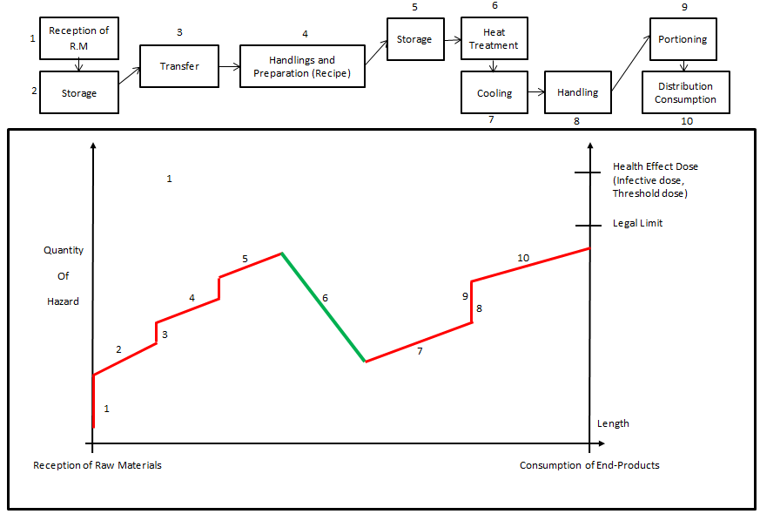
Figure 19

Figure 20 represents a relationship between the process flow and the level of the bacterial hazard relative to the infective dose and a legal limit in a situation where the FSMS has failed to eliminate the hazard or reduce it to an acceptable level.

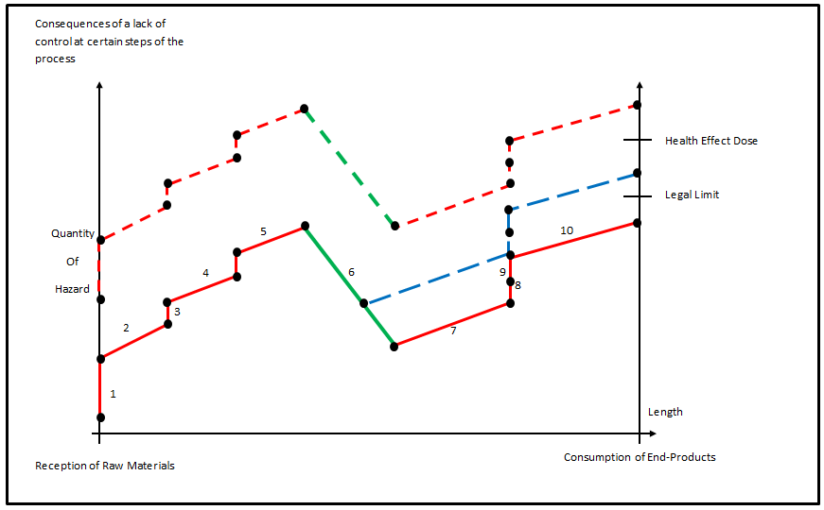
Figure 20

This is, in fact, what happens in an outbreak of foodborne disease.

4.6.3 The Epidemiological Dimension

Epidemiological data on those factors that are known to have contributed to outbreaks of foodborne disease or practices or situations that have led to outbreaks have been termed as ‘contributory factors’.^{[Reference]} These ‘contributory factors’ have been found to be remarkably similar over a range of incidents. Summarised below are the most common ‘contributory factors’ of outbreaks of food borne disease:-

Presence of hazards as inherent contaminants of foodstuffs at the outset of a process;

Introduction of hazards by direct contamination or by cross contamination;

Multiplication of hazards; and

Survival of hazards of a process intended to eliminate the hazard or reduce it to an acceptable level.

Epidemiology has confirmed that food-borne illness is the culmination of a predictable ‘chain of events’ wherein the Contributory Factors act alongside the hazards to cause foodborne illness. Figure 21 below summarises such a chain of events leading toward food-borne illness.

Figure 21 - Food Borne Illness as the Culmination of a Chain of Key Events

4.6.4 The Outcomes – A Practical Inspector’s Tool for Step 6

These insights lead to outcomes that make a critical contribution to the practice of Official Control HACCP Study:

  - The Contributory Factors and the Chain of Events, as demonstrated, reduce the inherent complexity of a manufacturing process and render it more amenable to understanding, thus easing the Step 6 of an Official Control HACCP Study. This is elaborated at ii. below.
  - Considering the list of hazards in terms of the Contributory Factors concept provides the inspector with a practical tool whereby they can ‘map’ the hazard onto the process flow diagram where it is relevant to do so. This creates a direct link between the hazard and the process flow diagram in terms of microbiology and epidemiology.
- The key steps within the chain of events renders the chain amenable to interventions (Control Measures on behalf of the FBO and Enforcement on behalf of Official Controls) which prevents the chain of events enfolding i.e. prevent food borne illness, thus being founded on epidemiology –. Official Control verification is effective as an Official Control as is required by Regulation (EC) 882/2004.

This practical approach is further elaborated below.

4.6.5 A Structured Approach to Step 6

Addressing the problem of Step 6 can be eased by reducing the issue to basics questions, i.e. what, where, when and how etc. Issues of significance and relevance can then be assessed using the process flow diagram as a framework or map. This approach breaks down step 6 into the following inspection skills:

- Hazard identification, i.e. what are the hazards?
- Hazard analysis, i.e. what are the significant hazards?
- Hazard mapping, i.e. when and where the hazards are relevant at process steps?
- Hazard causation, i.e. why the hazards are relevant at a process step?
- Hazard control, i.e. what needs to be done to eliminate the hazard or reduce it to an acceptable level?

This approach is founded in the microbiology and the epidemiology represented above. The answer to each question is a consequence of the answer to the preceding question. This logical approach ensures that the correct hazard is identified, analysed, mapped and its causation understood. Similarly, the outcome is a logically derived Control Measure that will actually eliminate the hazard or reduce it to an acceptable level.

4.6.6 Hazard Identification (What are the hazards?)

This aspect is relatively straightforward. A gap analysis is undertaken between the FBO’s own hazard identification and validated sources of information which define and describe the hazards associated with the same or similar products and processes. Examples of such sources include:

- Published epidemiological data;
- Food microbiological textbooks; and
- Advice from relevant specialist sources.

Officers should be aware of the problems associated with generic groupings of hazards such as ‘microbiological, chemical and physical’ etc. Bacteria, for example, have different physiological growth requirements which in turn mean that they are opportunistic contaminants under differing conditions. Consequently, species-specific control measures are sometimes required to control them. Officers should be prepared to undertake the appropriate research.

Allergens and additives are considered as types of chemical hazards.

4.6.7 Hazard Analysis (What are the Significant Hazards?)

The WHO Codex defined hazard analysis as follows:

Hazard analysis: The process of collecting and evaluating information on hazards and conditions leading to their presence to decide which are significant for food safety and therefore should be addressed in the HACCP plan.

WHO Codex 2003

These considerations relate to risk factors associated with the identified hazards - the purpose being to identify the significant hazards. In practice, considerations will always include a combination of the following:

- The likelihood of the hazard occurring and its consequent effects – e.g. previous company/industry experience or complaints, epidemiological data;
- The severity of the hazard – e.g. life-threatening/mild; chronic/acute;
- Numbers potentially exposed to the hazard – e.g. lot size; distribution;
- Age/vulnerability of those exposed – e.g. young/elderly; allergies
- Survival or multiplication of micro-organisms of concern;
- Production or persistence in foods of toxins, chemicals or physical agents;
- Source or cause of the hazard or conditions leading to the above.

In verifying hazard analysis, officers are referred to the current establishment profiling where much of this information was recorded.

4.6.8 The Practical Problems of FBO Risk Assessment

Since the WHO-Codex guidelines on HACCP were revised and with the advent of BRC and ISO2203 accredited FSMSs, it has become commonplace to introduce a measure of quantification (i.e. Risk Assessment) to step 6.

Figure 22 below, which summarises this process, is presented in the form of a ‘Risk Quadrant’ which is a simple formulation of the Risk Assessment Process, where risk is plotted as some function of the likelihood of an incident and the consequences of an incident.

Figure 22 – The Risk Quadrant

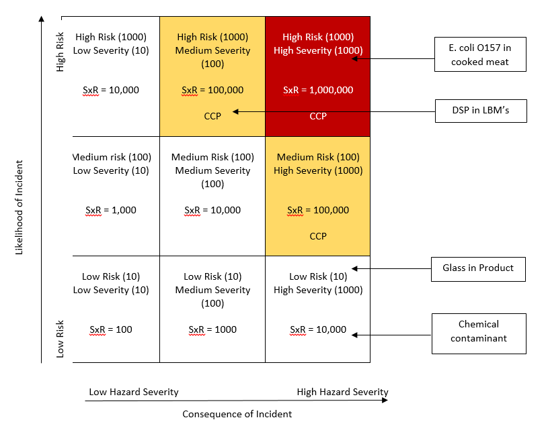

This process should be approached with caution as errors at this step can lead to significant hazards not being subject to HACCP Principle 2, i.e. Critical Control Point determination. A common error is for such Risk Assessments to be undertaken by unqualified personnel and/or on the basis of incomplete information.

Where inspectors come across this approach, they are advised to verify the process in sufficient detail to determine whether or not significant hazards have in fact been discarded from HACCP Step 7, i.e. Determination of Critical Control points.

4.6.9 Hazard Mapping (Where and When are the Hazards Relevant at Process Steps?)

As explained above, the outcome of the epidemiological-based Contributory Factors and key chain approach is that a number of descriptors of the Contributory factors emerge as a practical inspection tool that can be deployed to verify the relevance (in terms of the epidemiology of foodborne disease or otherwise) of hazards at any step within the process flow.

The relevance of a hazard to a step in the process flow or prerequisite programme is identified by identifying the relevant Contributory factor:

Presence – A hazard which is likely to be an inherent contaminant of the food at the outset;

Introduction: - A hazard introduced by contamination at a particular step of the operation, either via direct or indirect cross contamination.

Multiplication – A hazard may increase, e.g. by microbiological growth or toxin production, at a particular step;

Survival – A hazard might survive a particular step designed to eliminate it or reduce it to an acceptable level.

N.B. This is applicable to both generic hazards (prerequisite programmes) and to food-specific hazards (HACCP Control Chart)

These ‘Contributory factors’ have been condensed by SFELC into the pneumonic of P.I.I.M.S.

These ‘Contributory Factors’ can also be integrated into a structured algorithm. This practical tool for inspectors can be applied to the process/personnel and waste flows and/or prerequisite programme, in order to identify whether the hazards are relevant at the process step or prerequisite in question.

The algorithm in Figure 23 below may be used to verify the relevance of a hazard at any step in the process flow(s).

Figure 23 – Algorithm for Considering the Relevance of Hazards at Process Steps and Prerequisite Programmes

Core Question: Is the Hazard Relevant to this process step or this location?
(Applied to prerequisites or the process flow)

Yes
P. Presence by Inherent Contamination
Usually only relevant at initial steps
Relevant Hazard

No
Yes
Relevant Hazard

I. Introduction by Direct Cross Contamination

No
Yes
I. Introduction by Indirect Cross Contamination
Relevant Hazard

No
M. Multiplication
Yes
Relevant Hazard

Usually only relevant at delay steps

No

Yes
S. Survival
Relevant Hazard

No

No relevant hazard at this step/location

The outcome of this process is the Hazard Map. The hazards associated with the products and the processes have been considered in terms of each process step and in terms of the prerequisite programmes associated with that step. Where a hazard in terms of a Contributory Factor (s) is/are considered to be relevant to a step etc., then the hazard has been identified as relevant in the terms of the Contributory Factor at that step. This process proceeds through all of the process and the personnel flows, together with the prerequisite programmes. Figure 24 demonstrates the process of hazard mapping.

Figure 24 – Hazard Mapping (Microbiological)

Hazard Mapping (Microbiological)
Manufacturing |  | Fish Products Smokery
Delivery (a)(b)(c) |  | Delivery (a)(b)(c)
Storage (b)(c) |  | Storage (b)(c)
Preparation (b)(c) |  | Fillet and De-bone(b)
Processing (b)(c)(d) |  | Brine/Cure(c)(d)
Post Process (b)(c) |  | Smoke (d)
Storage (b)(c) |  | Chill (c)
Distribution (b)(c) |  | Vac Pack (b)(c)
Customer (b)(c)(d) |  | Store (c)
 |  | Distribution (b)(c)
 |  | Customer (b)(c)(d)

Key: (a) Present (b) Introduction (c) Multiplication (d) Survival

The inspector is able to verify exactly where the significant hazards are relevant within an establishment.

4.6.10 Hazard Causation (How relevant are hazards at a process step?)

It is recommended that hazard causation is conducted as a relatively straightforward process of deduction, where the starting point is the hazard mapping of the position of the hazard in the process flow diagram and the relevant descriptor used as the basis for deducing the causation. It is recommended that this is confirmed during the inspection reality check.

4.6.11 Hazard Control Measures. (What needs to be done to eliminate the hazard or reduce it to an acceptable level?)

Control measures must eliminate the identified significant hazards or reduce them to acceptable levels. Processes that do not achieve this objective are invalid as control measures.

Verification is a deductive process and an extension of the HACCP Step 6 process outlined above. By considering the relevant and significant hazards together with their Contributory Factors in the context of causation, the control measure can be logically and accurately deduced. Figure 25 below exemplifies this process.

Figure 25 – Contributory Factors and Controls

Contributory Factors | Causation | Control Measure
Inherent Contamination | Contamination at Source | Elimination or reduction to acceptable Levels at Source
Direct or Cross Contamination | Process whereby hazard is transferred directly or indirectly from a contaminated sources to a RTE product | Spatial or temporal Separation of source or vehicle and RTE product and/or cleaning and disinfection
Survival | Failure of a process step to kill the hazard | Process step that kills the hazard
Multiplication | Time and/or temperature promoting multiplication | Time and/or Temperature arresting multiplication

A structured aide memoire for Step 6.

The template for an aide memoire that inspectors may use to verify an FBO’s own approach to step 6 during an official control HACCP study is included in Annex G.

4.6.12 Chemical and Physical Hazards

The above approach is also used to address Step 6 in terms of chemical and physical hazards. Such categories of hazards are also addressed according to the same process, i.e.

- Hazard identification, i.e. what are the hazards?
- Hazard analysis, i.e. what are the significant hazards?
- Hazard mapping, i.e. when and where the hazards are relevant at process steps?
- Hazard causation, i.e. why the hazards are relevant at a process step?
- Hazard control, i.e. what needs to be done to eliminate the hazard or reduce it to an acceptable level?

It should be noted that both chemical and physical hazards must contaminate products for there to be a food safety issue. With physical hazards, there often is an inherent contamination. Typical examples of chemical cross contamination include allergenic residues on machinery and biotoxin accumulation where shellfish are transferred into contaminated waters. These hazards can survive processes intended to eliminate them or reduce them to acceptable levels. Examples include the sieving of flour to remove stones and the separation of product lines containing allergens. Such hazards can actually also multiply, e.g. a metallic foreign object being splintered into multiple shards within a reversing dough breaker, or marine biotoxins increasing where shellfish are conditioned while exposed to direct sunlight.

4.7 Verifying Step 6 – Listing of All Hazards and Control Measures

Relevant Inspection Stages: Preparation

With the advent of ISO 22003, the concept of operational prerequisite programs (OPPs) is becoming commonplace, in fact in some food manufacturing establishments OPPs have completely replaced all CCPs. The consequence is the need to depart from the established structure of a WHO Codex based HACCP study which progresses from step 6 to step 7, by the insertion of a new step relating to OPPs before progressing onto step 7. At the time of writing there is not settled industry wide conception of OPPs. However, what is clear is that OPPs are intended to embody the control measures for significant hazards that are not amenable to control at discreet points in space and time i.e. at critical control points. Such hazards may be mapped onto the process flow diagram as relevant at a number of process steps i.e. they may be “site wide” hazards. It has also become appropriate to consider whether the hazards at the various process steps can be amenable to on-line continuous monitoring (i.e. in real time) and by reference to a discreet i.e. numeric type critical limit.

Figure 26 below is suggested as a practical tool for inspectors to verify an FBO’s decision to address a hazard via an OPP or via a CCP

Figure 26 Decision tree for the categorisation of prerequisites, operational prerequisites and control measures at CCPs

Questions 1 and 2 focus on hazards at each process step
Questions 3 and 4 focus on control measures
No
No
Q4
Is the frequency of monitoring/checking the control measure sufficient to enable immediate corrective action to be taken?
Yes
Manage the hazard by using a defined control measure at the Critical Control Point
Q1 - Is this is a significant food safety hazard?
No
Manage the hazard by using a defined Prerequisite Programme

Yes

Q2 - Is this is hazard specific to the process step?
No

Yes

Q3 - Is it possible to establish a critical limit for the control measure?
Manage the Hazard by using a defined Operational Prerequisite Programme
No

Q4 – Is the frequency of monitoring/ checking the control measure sufficient to enable immediate corrective action to be taken?
No

Manage the Hazard by using a defined Control Measure at the Critical Control Point
Yes
4.8 Verifying HACCP Step 6 – Verification of the Determination of Critical Control Points

Relevant Inspection Stages: Preparation

The verification of the determination of Critical Control Points is critical to the verification of a FSMS. Figure 27 below reproduces The WHO-Codex Decision Tree, which is used for the purposes of this verification. The inspector applies each significant hazard to every step within the product process flow to the decision tree.

Figure 27 - Decision Tree for Verifying the Determination of CCPs

Do preventative control measures exist?
Q1

Yes
No
Modify step, process or product

Is control at this step necessary for safety?
Yes

No
Not a CCP
Stop

Is the step specifically designed to eliminate or reduce the likely occurrence of a hazard to an acceptable level?**
Yes
Q2

No

Could contamination with identified hazard(s) occur in excess of acceptable levels or could these increase to unacceptable levels?**
Q3

Yes
No
Not a CCP

Stop

Will a subsequent step eliminate identified hazard(s) or reduce likely occurrence to acceptable level(s)?
Q4

Critical Control Point
Yes
No

Not a CCP
Stop

One common error is the omission of Q3. Q3 performs a vital function i.e. the determination of whether the hazard is present at unacceptable levels or may increase to unacceptable levels. In considering the increase in the hazard, the processing environment should be taken into account (e.g. personnel and equipment which represent a source of contamination).

4.9 Verifying HACCP Steps 8 to 12 (i.e. Critical Limits, Monitoring Systems, Corrective Actions and Record Keeping)

Relevant Inspection Stages: Preparation and Main Inspection

HACCP Steps 8 to 10 and 12, relate to activities performed at CCPs. Verification may be performed as a straightforward process of compliance auditing, using the algorithm in Figure 28 below.

Figure 28 - HACCP Steps 8 to 10 and 12

Is/are the hazards correctly described and are control measures and the critical limits validated?

Are the monitoring and corrective action procedures sufficient?

Is the actual monitoring practice consistent with the written procedures?
Are the records of monitoring, corrective actions and verification consistent with written procedures?

CONFORMANCE
No
No
No
No

NON-CONFORMANCE?
Yes
Yes
Yes
Yes

Glossary

Term | Definition
Evidential Triangulation | A technique whereby two or more sources of evidence are used to establish the reality in a given situation.  As well as being applicable to every element within the FSMS, the technique of triangulation can also be applied to different sources of evidence. Where there is confirmation between three or more sources of evidence, the findings have been shown to be more robust.
Food Safety Management System (FSMS) | The interrelated elements that are designed and applied by a Food Business Operator to prevent illness and/or prejudice caused by the consumption of food.  These elements include policies, procedures, practices, processes, objectives, methods, controls, roles, responsibilities, relationships, documents, records and resources.  In practice, a FSMS may combine the following 4 main components:  - Prerequisite Programmes;  - Product Disposition Plans;  - HACCP Plan; and  - Incident Management Plan
Gap Analysis | The key, underpinning concept of Official Control Verification. It is the process whereby the officer compares and contrasts the aspects of the three Cardinal Points.  The process of GAP Analysis owes its origins to ‘reverse engineering’, i.e. the disassembling of a product or process into its elemental constituents, in order to understand how they are intended to fit together and operate. In the context of FSMS verification, the officer should ‘reverse engineer’ the FBO’s own HACCP study.
Official Control HACCP Study | The application of the WHO-Codex defined steps and principles of HACCP to a product and/or process, undertaken by the Food Authority.  It is a process as well as an outcome.  The process is a key inspection and audit ‘tool’ and focuses upon the BO’s products and processes.  The outcome of the process is one of the Cardinal Points of Official Control Verification, providing a key reference that is both external and independent of the FBO.  NB. Term HACCP Study is derived from the WHO-CODEX
Official Control Verification | The overall process of verification of the FBO’s FSMS which is carried out by the Food Authority.
Product Disposition | A critical and integral aspect of process control. It relates to the quantity of all components of the product, their location and their progress through the entire process. Product disposition encompasses the master manufacturing instructions, traceability and lot marking.
Reality Check | An audit of compliance with the FBO’s FSMS undertaken by the Food Authority. One of the ‘cardinal points’ of ‘Official Control Verification’  The process of assessing non-compliances observed during inspection with conformance with the Officer’s HACCP Study is also a process defined as Reality Check.
Three Cardinal Points of Official Control Verification | - An Official Control ‘HACCP Study’ conducted by the officer;  - The Food Safety Management System (FSMS) created by the food business operator; and  - The practical operation of food production process
Validation | Obtaining evidence that a control measure or combination of control measures, if properly implemented, is capable of controlling the hazard to a specified outcome
Verification | The application of methods, procedures, tests and other evaluations, in addition to monitoring, to determine whether a control measure is or has been operating as intended

Annex A Codex HACCP Steps

HACCP Step | Task | HACCP Principle
Step 1 | Assemble HACCP team
Step 2 | Describe product
Step 3 | Identify intended use
Step 4 | Construct flow diagram
Step 5 | Confirm flow diagram
Step 6 | List all potential hazards associated with each step;  Conduct a hazard analysis;  Consider control measures | Principle 1
Step 7 | Determine critical control points (CCPs) | Principle 2
Step 8 | Establish critical limits for each CCP | Principle 3
Step 9 | Establish monitoring for each CCP | Principle 4
Step 10 | Establish corrective actions | Principle 5
Step 11 | Establish validation, verification and review | Principle 6
Step 12 | Establish documentation and record keeping | Principle 7

Annex B Business Profiling

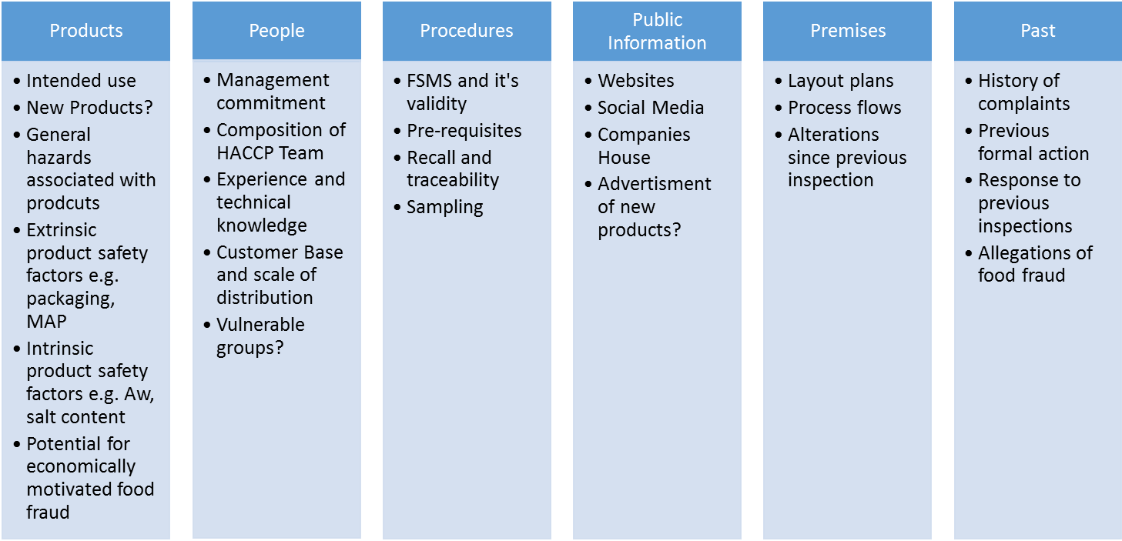

Annex C Random Number Page

Week
1 | 88 22 87 58 39 82 13 51 4 29 36 92 85 17 69 37 11 70 55 02
2 | 52 49 94 07 83 16 15 80 75 93 81 61 62 41 28 77 35 63 19 48
3 | 07 26 93 35 54 51 05 60 28 94 12 23 24 62 36 64 69 88 40 10
4 | 46 73 97 80 32 71 01 09 48 87 67 65 99 95 08 85 04 06 55 37
5 | 94 53 43 96 16 49 88 61 93 71 34 48 50 59 62 40 55 01 23 67
6 | 98 25 68 75 57 52 28 54 73 58 19 81 37 56 09 92 07 90 84 42
7 | 29 78 14 89 60 97 77 87 85 70 30 27 22 18 10 32 69 21 51 44
8 | 71 39 03 66 80 47 05 13 72 20 31 02 91 35 95 46 15 36 33 04
9 | 63 41 86 83 65 17 79 99 64 08 24 76 45 38 74 26 82 11 12 06
10 | 39 53 37 67 54 36 73 84 15 99 88 68 58 60 55 06 23 10 09 96
11 | 27 72 13 91 97 02 28 85 30 64 48 98 24 31 95 35 63 83 49 57
12 | 32 01 07 90 26 03 65 80 87 74 76 25 04 20 79 45 46 05 34 66
13 | 61 77 14 40 12 52 71 81 93 29 99 75 51 50 18 86 08 92 94 33
14 | 22 16 42 38 17 62 47 78 41 89 82 44 43 70 56 11 59 21 69 19
15 | 19 17 34 41 29 92 12 22 89 05 18 71 93 47 99 85 69 20 57 87
16 | 67 08 72 73 91 60 49 13 06 58 15 87 16 54 78 11 66 33 46 39
17 | 07 88 48 75 30 59 36 14 32 40 51 97 24 44 80 01 52 04 84 71
18 | 27 98 43 74 21 23 70 86 79 56 09 65 96 26 61 28 68 42 02 92
19 | 95 77 25 35 45 62 76 86 39 50 55 90 31 63 10 81 94 82 53 87
20 | 64 20 95 17 49 97 50 58 55 14 56 54 29 69 71 74 33 12 42 82
21 | 80 08 39 79 24 75 19 57 02 94 28 18 67 81 91 84 31 30 86 49
22 | 77 35 82 48 13 72 34 52 92 65 96 90 06 38 63 85 51 32 27 13
23 | 41 04 45 66 46 68 15 83 10 61 01 03 21 99 47 88 09 05 60 32
24 | 62 93 76 07 98 73 70 44 26 23 16 97 40 25 11 36 59 37 87 48
25 | 19 51 43 46 68 40 88 33 26 27 21 58 60 90 34 30 52 07 65 73
26 | 18 53 48 05 28 01 80 42 25 89 59 66 77 64 15 38 57 31 91 42
27 | 94 16 23 73 32 83 71 17 76 63 49 10 61 06 98 47 70 22 82 18
28 | 79 84 67 74 72 56 55 87 09 94 96 12 75 95 29 41 08 44 50 23
29 | 78 93 39 99 97 81 85 86 37 62 14 02 20 24 45 54 35 04 03 36
30 | 36 38 52 79 15 73 71 66 01 67 03 53 70 99 07 57 29 75 27 45
31 | 96 84 92 81 61 89 43 35 11 24 91 63 26 55 74 23 46 68 54 98
32 | 64 95 04 06 94 17 78 42 56 80 25 16 69 83 09 33 34 12 87 77
33 | 72 28 62 86 31 22 65 40 10 90 85 13 41 47 97 60 37 51 59 14
34 | 19 05 02 30 21 76 44 29 49 93 32 58 08 82 18 39 20 88 50 48
35 | 09 86 11 65 92 32 23 19 20 61 33 75 69 82 35 84 14 59 17 58
36 | 90 99 79 97 54 02 06 44 37 07 10 52 60 24 63 22 45 98 43 47
37 | 68 66 36 42 27 28 29 94 93 91 40 31 71 80 30 37 62 49 96 25
38 | 85 21 81 51 57 01 13 16 34 08 73 18 72 26 76 95 87 74 64 55
39 | 39 56 04 48 70 67 05 53 03 78 41 38 77 83 12 50 88 15 89 46
40 | 75 25 32 05 10 82 07 52 06 13 38 80 91 44 39 04 72 19 22 76
41 | 27 28 78 23 03 02 73 30 42 95 29 77 65 88 94 90 53 63 97 81
42 | 61 70 67 17 93 45 59 24 35 79 16 14 21 26 64 46 19 69 86 20
43 | 66 50 92 51 96 08 84 12 36 62 55 01 68 58 56 47 40 31 71 60
44 | 99 41 54 37 83 89 43 15 34 57 18 11 49 87 09 74 98 33 85 48
45 | 68 58 23 32 73 75 40 91 29 20 27 63 05 13 72 98 59 03 71 66
46 | 87 33 44 37 80 61 86 45 11 47 48 15 60 88 55 76 09 34 67 17
47 | 51 26 94 82 28 65 41 90 70 01 39 74 62 43 42 12 38 69 92 93
48 | 21 81 49 35 57 84 08 89 77 53 83 16 97 99 04 18 06 54 14 19
49 | 52 22 96 56 07 24 85 10 36 10 64 95 78 31 25 79 02 30 50 46
50 | 41 17 25 81 18 45 83 96 15 92 58 84 75 12 29 59 56 91 98 49
51 | 77 30 66 90 20 68 50 82 57 78 27 22 89 34 03 53 70 16 11 86
52 | 47 72 33 43 76 42 63 79 44 14 21 61 13 39 38 31 02 52 74 19

Annex D Resource Requirements

1.0 Calculation of Minimal Time Required for Official Control Verification

The minimum time (Mt) required for Official Control Verification shall be calculated as follows:-

MT = DRT + ADRT + OST + AOST + FFSMS + AFTE

Where:

DRT = | Document review time (for Document Review stage contributing to Official Control Verification, including Official Control HACCP Study)
ADRT = | Additional Document Review time for each additional HACCP study
OST = | On-site Official Control verification time (for Reality check stage contributing to Official Control Verification, including Official Control HACCP Study)
ADOST = | Additional on-site Official Control verification time for each additional HACCP study
FFSMS = | Factor for absence of FSMS.
AFTE = | Additional Factor for number of employees
 | By reference to tables one (Process categories) and then table two (time factors) below.

Table 1 – Process Categories

Process Codes | Technology | Example of Technology
A | Non-RTE POAO | Abattoir, Shellfish dispatch.
B | RTE POAO shelf-life extended by established validated heat treatments (e.g. ACMSF 6 log reduction 90^{O}C for 10 minutes etc. Composite products made from RTE POAO. | Cooking of POAO. Bakery (Composite products containing POAO e.g. pies and pasties). Hot smoked POAO. Pasteurisation of dairy products by established batch or HTST processes. Cheeses, pates and terrines etc.
C | Cook-chill | Ready meals preserved by chill holding & intended for regeneration at point of consumption.
D | RTE POAO preserved by canning, vacuum and MAP, products with shelf life extended by minimal thermal processing, products containing critical ingredients, Including the use of ‘Hurdle-technology’ Products subject to minimal processing in combination with critical hygiene controls. Shellfish depuration. POAO placed upon the market untreated. | Canned POAO and composite products, cold smoked POAO, vacuum and MAP preservation, POAO not subject to a thermal process validated to achieve 6 log bacterial reductions (e.g. rare burgher manufacture). Sushi and sashimi.

2.0 Additional HACCP Study

Addition of an ADRT and ADOST is contingent upon the need to undertake additional Official Control HACCP studies of FBO HACCP studies that are substantively different from the first FBO HACCP study.

A key point is that although the food products may be identical or very similar, the food science and technology embodies different hazards and/or different levels of risk and complexity in production. Inspecting Officers should exercise their professional judgement. It is clear that the additional of ADRT and ADOST would be apposite in the following circumstances although this is not intended to be definitive nor exhaustive and inspecting officers should use their professional discretion reviewing the FBOs and their own product descriptions (i.e. stage one) to discriminate between FBO HACCP Studies that require ADRT and ADOST and those that may not:-

- Where a different FBO HACCP Study embodies the inclusion of a different allergenic ingredients. An example of this is peanut flour as opposed to wheat or soya flour.
- Where a different FBO HACCP study entailed the use of ingredients with differing hazard profiles. An example of this is distillation, wherein whisky includes barley and artisan Scottish gins might include a range of wild-foraged botanicals with unique toxicological profiles and/or requiring Novel Food licensing.
- Where a different FBO HACCP Study was predicated upon new or emergent food science and technology (requiring specific validation). Examples of this are burger production intended for the rare burger market and high pressure (non-thermic pasteurisation) of fruit juices.
- Where a different FBO HACCP study embodied substantively different science and technology. Example of this are hot smoking and cold smoking, pasteurised cheese production and unpasteurised cheese production.
- Where a different FBO HACCP Study utilised preservation techniques that are substantively different. An example of this is chilled preservation and shelf life extended by Vacuum packaging, curing using different combinations of additives such as nitrites, phosphates and salt/sugar etc.
- Where and FBO HACCP Study involved different species of fish or shellfish and/or shellfish derived from category A and B classified waters. An example of this is a fish ready-meal containing scombroid species and another containing whitefish, ready to eat mussels and oysters and mussels derived from category A and category B classified water.

Technology Category | DRT  (in FTE days) | ADRT  (in FTE days) | OST  (in FTE days) | ADOST  (in FTE days) | FFMSS -Factor for absence of FSMS  (in FTE days) | AFTE -Number of Employees  (in FTE days) | For each Additional Site Visited
A | 0.25 | 0.25 | 0.75 | 0.25 | 0.5+ | 1 to 19 = 0  20 to 49 = 0.5  50 to 79 = 1.0  80 to 199 = 1.5  200 to 499 = 2.0  500 to 899 = 2.5  900 to 1299 = 3.0  1700 to 2999 = 4.0  3000 to 5000 = 4.5  >5000 = 5.0 | 50% of minimum on-site audit time
B | 1.00 | 0.25 | 1.00 – 1.50 | 0.50 | 0.5+ |  | 50% of minimum on-site audit time
C | 1.00 | 0.25 | 1.00 – 2.0 | 0.50 – 1.00 | 0.5+ |  | 50% of minimum on-site audit time
D | 1.0-1.5 | 0.50 | 2.0 – 3.5 | 0.50 – 1.00 | 0.5+ |  | 50% of minimum on-site audit time
Table Two - Time Factors

3.0 Worked Example

An Inspecting Officer is planning a forthcoming inspection of a smokery and begins by reviewing the Business Profiling information and the product descriptions. In summary the establishment is engaged in both hot and cold smoking of salmon and trout and extends the shelf life to 42 days by a combination of chill holding and vacuum packaging. The establishment also manufactures terrines and pates using fish trimmings and cream cheese. There are 43 employees. The establishment has been verified as achieving greater than broad-compliance for 5 years and holds SALSA accreditation.

The officer recognises that hot and cold smoking of salmon and terrine manufacture etc. constitute three distinct processing categories necessitating three distinct HACCP studies and therefore proceeds as follows:-

Where: MT = DRT + ADRT + OST + AOST + AFTE

∴ MT = 5 where DRT (= 1.0) + ADRT (= 0.25+0.25) + OST (= 2.0) + AOST (= O.5+0.5) + FFSMS (0) + AFTE (= 0.5) with no additional site factor.

Exclusions

The following are excluded:-

- Travelling
- Report writing
- Enforcement

Annex E Further Resources

Advisory Committee on the Microbiological Safety of Food | www.acmsf.food.gov.uk
British Retail Consortium | www.brcglobalstandards.com
British Sandwich Association | www.sandwich.org.uk
Campden and Chorleywood | www.campdenbri.co.uk
Chilled Food Association | www.chilledfood.org
Codex Alimentarius | www.codexalimentarius.org
Food Standards Agency | www.food.gov.uk
Food Standards Scotland | www.foodstandards.gov.scot
Health Protection Scotland | www.hps.scot.nhs.uk
Institute of Food Science and Technology | www.ifst.org
PAS 96 | www.food.gov.uk/sites/default/files/pas96-2014-food-drink-protection-guide.pdf
Scottish Association of Master Bakers | www.scottishbakers.org

Annex F Model Inspection Forms

PRE-INSPECTION DOCUMENTATION SCHEDULE

To: Name and address of FBO

Your food business is due to be inspected shortly. To save time during the inspection and to reduce disruption to your business on the day, it would be helpful if you could provide the information indicated below in advance. Requested information should be sent to:

Officer’s business address:

For the Attention of: Officer’s name

The information requested should be provided no later than: Date information required

If you have any questions, please contact the aforementioned officer at:

Officer’s phone number:

Officer’s email address:

1 |  | COMPANY PROFILING
1.1 | Identity and contact details, name, address, telephone number(s), email address and details for:
1.1.1 | Food business operator (the legal person conducting the business):
1.1.2 | Managing Director:
1.1.3 | Company Secretary:
1.1.4 | Quality/Safety Assurance Manager:
1.1.5 | Person responsible for authorising conformance with food safety management procedures
1.2 | List of current product range:
1.3 | List of current customers:
1.4 | List of current suppliers:
1.5 | Master manufacturing instructions:
1.6 | Current site layout/plan:
2 | HACCP-ASSOCIATED DOCUMENTATION
2.1 | HACCP Plan
2.2 | Current HACCP Plan
2.2.1 | Including current process flow diagrams
2.2.2 | Including standard operating procedures for each CCP/Operating manuals for equipment at each CCP
2.2.3 | Including monitoring records for each CCP since [date]
2.2.4 | Including corrective action records for each CCP since [date]
2.3 | Verification Activity
2.3.1 | Operating instruction manuals for HACCP control measurement
2.3.2 | Documentation from last review of HACCP Plan
2.3.3 | Minutes of last 3 meetings of the HACCP Team
2.3.4 | Documentation in relation to the last process flow diagrams review/validation
2.3.5 | Documentation in relation to new product design  (from the date of the last inspection)
2.3.6 | Documentation in relation to the last 3 internal audits of the HACCP Plan
2.3.7 | End product sampling and assay plan
2.3.8 | Results of end-product assay(s) from the date of the last inspection:
 | - Microbiological
 | - Chemical
2.4 | Documentation associated with validation: process capability assessment
3 | PREREQUISITE PROGRAMMES
3.1 | Training
3.1.1 | Training policy
3.1.2 | Records in relation to training:
 | - Induction training
 | - HACCP training
 | - CCP/SOP training
 | - Food hygiene training
3.2 | Staff Hygiene
3.2.1 | Policy on staff hygiene (e.g. protective clothing)
3.2.2 | Staff Exclusion Policy
3.3 | Cleaning and Disinfection
3.3.1 | Cleaning and disinfection procedures
3.3.2 | Cleaning and disinfection schedules
3.3.3 | Specifications for all cleaning and disinfection agents
3.3.4 | Environmental cleaning and disinfection assays e.g. swabbing
3.4 | Water Supply
3.4.1 | Results from microbiological assay of the water supply
3.4.2 | UV light renewal records
3.4.3 | Filter renewal records
3.4.4 | Procedure for chemical dosing
3.5 | Pest Control
3.5.1 | Pest control policy/contract
3.5.2 | Results of pest control inspections since the date of the last LA inspection
4 | OTHER GOOD MANUFACTURING PRACTICES
4.1 | Foreign Body Control
4.1.1 | Policy procedure on foreign body control
4.1.2 | Glass/Perspex control procedure
4.1.3 | Results from glass/Perspex audits undertaken since last LA inspection
4.1.4 | Results from foreign body control measures e.g. metal detection/scanning
5 | TRACEABILITY, PROVENANCE AND LOT MARKING
5.1 | Traceability procedure
5.2 | Lot marking procedure
5.3 | Records in relation to last traceability test/challenge
5.4 | Procedures for product recall conforming
5.5 | Records in relation to last product recall test/rehearsal
5.6 | Procedure(s) for managing non-conforming product e.g. disposition, control, quarantine, re-working etc
5.7 | Records in relation to non-conforming product since the last LA inspection
5.8 | Procedure for supplier approval
5.9 | Last supplier approval
5.10 | Last supplier audit for each supplier
6 | CALIBRATION
6.1 | Procedure for calibration of HACCP control measure and monitoring equipment
6.2 | Calibration records
7 | ALLERGEN MANAGEMENT AND CONTROL
7.1 | Policy on allergen control
7.2 | Method for informing customers in relation to allergenicity of product
7.3 | Procedure for procurement in relation to allergen control
7.4 | Procedure for controlling cross contamination in relation to allergens

BUSINESS INFORMATION AND PROFILE FORM

PART 1

 | BUSINESS INFORMATION
 |  | 1.0 |  | OFFICER TO RECORD N/A IF NOT APPLICABLE
 |  |  | Business Name:
 |  |  | Full Address:
 |  |  | Telephone Number:
 |  |  | Confirm if Business
 |  |  | is subject to Regulation
 |  |  | (EC) 853/2204 |  | Yes No

2.0 | Inspection Rating : | Initial : |  |  |  |  |  |  |  |  |  |  | Food Law Code of
 |  | Date : |  |  |  |  |  |  |  |  |  |  | Practice
 |  | Rating :
 | Significant Risk Factor : | Yes |  |  |  | No
 | Vulnerable Groups Factor: | Yes |  |  |  | No
3.0 | Premises Address :
4.0 | Trading Name :
5.0 | Fax No.
6.0 | Details of Proprietor :
 | (include Name(s) of
 | Partner(s))
7.0 | Proprietor’s Address :
 | (if different to above)
8.0 | Registered Office Address
 | and Tel No. if applicable :
 | (and if different to above)
9.0 | Name of Company Secretary
 | if applicable :
 | (and if different to above)
10.0 | Out of Hours Contact Details |  | (a) Name |  |  |  |  | ________________________________
 |  |  | (b) Landline |  |  |  |  | ________________________________
 |  |  | (c) Mobile |  |  |  |  | ________________________________

PART 2

PREMISES PROFILE
11.0 | Type of foods produced/ manufactured/processed:
 | (Delete as necessary)
 | Note use of raw meats & ready to eat foods. Use of raw eggs and shellfish products for high risk foods.
12.0 | Type of process – thermal processing of low acid foods, pasteurisation, hot holding, re-heating/regeneration, cook chill/cook freeze, brining, smoking, vacuum packing, modified atmospheric packing.  (Officer to describe all elements of processing).
13.0 | Description of premises (layout, facilities, general suitability)  Note - Officer to append schematic diagram of premises.

PART 2

PREMISES PROFILE (Cont’d)
14.0 | Suppliers (specify also products) :
15.0 | Scale of distribution (nature – eg, local retailers/caterers and number) :  (Include identity of customers, details of chain and extent of supply i.e. local, regional export etc.)
16.0 | Does business sell food direct to the final consumer? |  | Yes* |  | No*
 | Or sell food by wholesale? |  | Yes* |  | No*
 | Or export? |  | Yes* |  | No*
 | (*Officer to tick as is necessary)
17.0 | Production quantity (throughput)  Officer to record the verified weekly throughput.

18.0 | Identity of particularly vulnerable groups.
19.0 | Management Control.
 | (Officers should seek to obtain copies of documentation of management control documents. Section 14 of the Food Hygiene (Scotland) Regulations 2006 and Section 32 (5) of the Food Safety Act 1990 confers the power to examine any records in whatever form they are held in relation to a food business.)
 | FSMP/HACCP document produced/filed |  | Produced |  | Held on File
 | Prerequisite programmes documentation |  | Produced |  | Held on file
 | produced/filed
 | Training records produced/filed |  | Produced |  | Held on file
 | Cleaning Schedules produced/filed |  | Produced |  | Held on file
 | Traceability System produced/filed |  | Produced |  | Held on file
 | Re-call Procedure |  | Produced |  | Held on file
 | Specify other Prerequisite Programmes
 | Other documentation produced/filed |  | Produced |  | Held on file
 | Specify

PART 2

PREMISES PROFILE (Cont’d)
20.0 | Special considerations (trading hours, production times, language, etc) :
21.0 | Approval conditions:-
 | Does the business comply with applicable approval requirements under Regulations (EC) 853 and 853/2004? Note any conditions of Approval.
22.0 | Is the business subject to a system of:
 | Internal Audit?
 | External Third Party Accredited Auditing?
 | Specify

PART 3

BLOCK INFORMATION

23.0 | What technical guidance does the business have access to in relation to:
 | 1. Evaluation of Shelf Life of Foods
 | Details:
 | 2. HACCP
 | Details:
 | 3. Vacuum and Modified Atmosphere Packing
 | Details:
 | 4. Food Fraud
 | Details:
 | 5. Good Manufacturing Practice
 | Details:
24.0 | Officer Notifications/Recommendations
 | Officer to record other observation(s) as appropriate (i.e. advice to next inspecting officer: Issues for consideration, Advice on format of next Intervention. Notification of any particular Guidance or Codes of Practice applicable etc.

PART 4 - SIGNATURES
Authorised as an accurate record of the business details at the time of the inspection.

Any person who intentionally obstructs any person acting in the execution of the Food Hygiene (Scotland) Regulations 2006 or, without reasonable cause, fails to give any person acting in the execution of this Act any assistance or information which that person may reasonably require of him/her for the performance of his/her functions under this Act shall be guilty of an offence.

Any person, who in purported compliance with any such requirement as is mentioned above, furnishes information which he/she knows to be false or misleading in a material particular or recklessly furnishes information which is false or misleading in a material particular, shall be guilty of an offence.

Proprietor/Proprietor’s Representative:
Date:
Inspecting Officer:
Date:
Proprietor/Proprietor’s Representative:
Date:
Inspecting Officer:
Date:
Proprietor/Proprietor’s Representative:
Date :
Inspecting Officer:
Date:
Proprietor/Proprietor’s Representative:
Date :
Inspecting Officer:
Date:

Signature of Proprietor
(or Proprietor’s Representative):
Name in Block Capitals:
Date:
Signature of Authorised Officer:
Name in Block Caps:
Date:
Signature of Line Manager
Reviewing Inspection:
Name in Block Caps:
Date:
Signature of Auditing Officer:
Name in Block Caps:
Date Audited:
HACCP ASSESSMENT CHECKLIST

PREPARATION

What evidence is there of management commitment to HACCP use?
HACCP TEAM
(Guidance Document Reference Figure 12)
Who was on the team?
Are all appropriate disciplines represented?
What is likely level of knowledge? (Evidence of training, qualifications, experience, etc)
Has external expertise been sought where necessary?
What is the decision making leverage of the HACCP team leader?

HACCP SYSTEM

How does the system fit in with the overall food safety control programme?
Does the company have a food safety policy?
Has the scope been clearly defined?
How is the system structured?

HACCP Principle 1 – CONDUCT A HAZARD ANALYSIS
Product Description
(Guidance Document Reference Figure 13)
Assessment | Objective Evidence
Has the product been described in safety terms?
What are the principles upon which the product & process safety are founded?
Are they scientific?
Have these principles been incorporated into product & process design?
How were control measures designed?
Who designs the products & the process?
Consider controlling factors & ‘hurdles’

HACCP PRINCIPLE 1 – CONDUCT A HAZARD ANALYSIS
Process Flow Diagram
(Guidance Document Reference Figure 16)
Is the process flow diagram (PFD) comprehensive?

How was the PFD verified for accuracy and by whom?
Are all raw materials and process/storage activities included in the flow diagram? (Rework can be included as an ingredient).

Have all activities been included?

Is the process flow diagram correct?

Have changes been made since the PFD was drawn up?
How does the HACCP Team get notified of changes to the process or product parameters?

How were the changes recorded and approved?

Were any changes discussed with the HACCP Team before implementation?
Are there rework opportunities and have they been included?
Have significant hazards been mapped onto PFD?
Have all raw materials (including rework) been included?
Have all process steps been considered?

HACCP PRINCIPLE 1 – CONDUCT A HAZARD ANALYSIS
Hazard Identification
(Guidance Document Reference Figures 23-25)
How was the hazard analysis conducted? (i.e. what Methodology)
Have the hazards been specifically identified by type/source or have they been generalised?

How did the team assess the likelihood of occurrence?
What information sources were utilised?
Have appropriate control measures been identified for each hazard?
Will the control measures control the hazards and how was this validated?
Are all the Control Measures in place at the plant level?

HACCP PRINCIPLE 2 – DETERMINE THE CRITICAL CONTROL POINTS
(Guidance Document Reference Figures 26-27)
How were the CCPs identified?

By expert judgement?

By the use of a decision tree? (Has the decision tree been used correctly?)

By the use of consultants?
Have all necessary CCPs been identified?
Did each identified hazard undergo a systematic consideration?
How are the hazards which are not controlled by CCPs addressed?

HACCP PRINCIPLE 3 – ESTABLISH CRITICAL LIMITS
(Guidance Document Reference Figure 28)
How were the critical limits established?

Is there evidence (experimental data, literature references, etc)?
What validation exists that the critical limits control the identified hazards?
Have critical limits been established for each CCP?

How do they differ from operational limits?

HACCP PRINCIPLE 4 – ESTABLISH A SYSTEM TO MONITOR THE CONTROL OF THE CCP
(Guidance Document Reference Figure 28)
Do monitoring procedures cover all CCPs?
Has the reliability of monitoring procedures been assessed where appropriate?
What is the status of monitoring equipment?
Is it evidenced as being in place and calibrated appropriately?
Are the CCP log sheets being used at all CCPs?
Have CCP log sheets been filled out correctly?
Is there any evidence that procedures are not being followed consistently?
Does the frequency of monitoring adequately confirm control?
Are the sampling plans statistically valid?

Are the sampling plans statistically valid?
Are statistical process control records being used to demonstrate that the process is in control on a day-to-day basis?
Check that records agree with stated activities
Are monitoring personnel and their deputies properly identified and trained?

How was the training undertaken?
Are the monitoring records being reviewed by designated appropriate reviewers?

HACCP PRINCIPLE 5 – ESTABLISH CORRECTIVE ACTIONS
(Guidance Document Reference Figure 28)
Have the corrective actions been properly defined such that control is regained?
What evidence is there to demonstrate that this is being done in the event of a CCP deviation?
Has corrective action been recorded and how is the effectiveness being verified?
How has the Authority for corrective action been assigned?
How is non-conforming product controlled and is this clearly recorded?
Are there clear disposition actions listed?

HACCP PRINCIPLE 6 – VERIFICATION PROCEDURES
(Guidance Document Reference Figure 15)
Have verification procedures been clearly and appropriately established?
How are these procedures communicated through the business?
Have responsibilities for verification procedures been allocated?
Are they being carried out effectively?
Are all CCPs covered by the verification programme?
Is the information on the HACCP Control Chart up to date?
Is there a formal system to trigger amendments?
Are control parameters being achieved?
Have process capability studies been carried out?
How is the data from HACCP being used to improve the system?
How is consumer complaint data being used within the verification system?
Is there a regular review of CCP failure and product dispositions?
Are prerequisite support systems included within the verification programme?

HACCP PRINCIPLE 7 – ESTABLISH DOCUMENTS AND RECORDS

What format is being used to document the system?
Does the documentation cover all of the HACCP system operation?
How is the documentation controlled with regard to update and issues, etc?
Are the records accessible?
Are the HACCP records clearly identified by unique reference numbers?
Are all documents accurate and current?
Are verification procedures documented?
How is change control managed?

REALITY CHECK INSPECTION FORM
Reality Check – Officer’s HACCP Study Principles 1-5 & 7

Business___________________________________________
Product___________________________________________
Date______________________________________________
Page one of_______________________________________

Step & PFD Verify | Awareness of Hazard? | Control Measure  (NB Knowledge & Reference to Critical Limits) CCPs Correctly identified? | Monitoring  (NB Knowledge & Reference to Critical Limits) | Corrective Actions  (NB Knowledge & Reference to Critical Limits) | Documented?

Reality Check Assessment – Officer’s HACCP Study - Principles 1-5 & 7

Business___________________________________________
Product____________________________________________

Step & PFD Verify | Awareness of Hazard? | Control Measure  (NB Knowledge & Reference to Critical Limits) CCPs Correctly identified? | Monitoring  (NB Knowledge & Reference to Critical Limits) | Corrective Actions (NB Knowledge & Reference to Critical Limits) | Documented?

Reality Check – Officer’s HACCP Study Principles 1-5 & 7
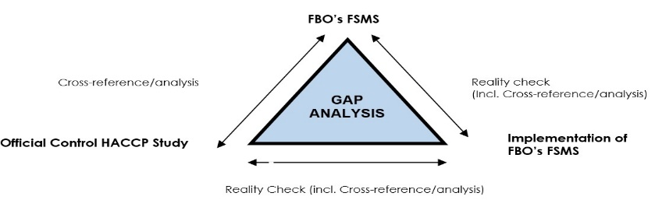
Business___________________________________________
Product___________________________________________
Date______________________________________________
CCP ______________________________________________

Record Sources of Evidence
Has the CCP been correctly identified?

Critical Limits (Appropriate, Achieved in Practice)

Monitoring (Appropriate Frequency, trained staff, consistent with written procedure)

Corrective Actions (Are these being actioned when required, consistent with written procedure)

Records (Accessible, correct version, completed correctly)
Is the CCP under control? Evidential Triangulation – record sources of evidence.

Reality Check – Officer’s HACCP Study Principles 1-5 & 7
Business___________________________________________
Product___________________________________________
Date______________________________________________
Process Step_______________________________________

Record Sources of Evidence
Has the Step been correctly identified? (PRP/OPP etc)

Controls and Limits (Appropriate, Achieved in Practice)

Monitoring (Appropriate Frequency, trained staff, consistent with written procedure)

Corrective Actions (Are these being actioned when required, consistent with written procedure)

Records (Accessible, correct version, completed correctly)
Is the step under control? Evidential Triangulation – record sources of evidence.

Reality Check – Traceability/Product Recall/Mass Balance

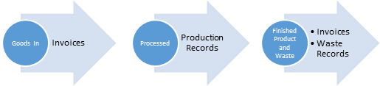
Business ___________________________________________
Product Traced ___________________________________________
Date ___________________________________________

Record Sources of Evidence
Can ingredients be traced back to intake and supplier (reverse Trace) or can all products produced with affected product be identified (forward trace)

Can the FBO identify all product which requires to be recalled?
Mass Balance
Ability to effectively identify and contact customers
Recommended improvements to system

Assessment HACCP Stage 3 & 7
Principle 6: Verification- Process Capability Assessment

Assessment | Objective Evidence

Principle 6: Verification – Product Shelf Life

Assessment | Objective Evidence
Basis of shelf life determination
Shelf Life Trials

Principle 6: Verification (Cont’d)

Assessment | Objective Evidence
External Audits
Internal Audits

Principle 6: Verification (Cont’d)

Assessment | Objective Evidence
Corrective Actions
Supplier Audits
Certification of Conformance

Principle 6: Verification (Cont’d)

Assessment | Objective Evidence
HACCP Review
Is system live?
When were PFDs tested for accuracy?
HACCP Team Meeting.
Is system live?

Principle 6: Verification (Cont’d)

Assessment | Objective Evidence
End Product Testing?*
Water Supply Assays?
* Cross reference to Process Capability Assessment

Inspection Aide Memoir

Approval Conditions
Premises Design and Layout

Regulations (EC) 852 & 853 2004

Assessment | Objective Evidence
Does design protect against post process recontamination?

High risk/low risk physical divides;

Linear Process flows;

Linear counter direction waste flows;

Size, distance between operations;

Approval Conditions
Premises Design and Layout

Regulations (EC) 852 & 853 2004 (Cont’d)

Intensity of the operation & throughput;

Effect of staff workflows. Protective clothing hanging?

Time separation with cleaning & Disinfection regimes – Cross-reference
Cross reference to layout schematic
Potable water supply

Approval Conditions
Premises Design and Layout

Regulations (EC) 852 & 853 2004 (Cont’d)

Assessment | Objective Evidence
Adequate No. of WHBs with H&C running water

Adequate No. of WCs
IVS

Ice-Making & store prevents contamination
Packing stored to prevent contamination

Approval Conditions
Premises Design and Layout

Regulations (EC) 852 & 853 2004 (Cont’d)

Assessment | Objective Evidence
Equipment clean & capable of cleaning & disinfection
Structure clean & capable of being cleaned & disinfected

Consider walls floors, ceilings doors etc

Approval Conditions
Premises Design and Layout

Regulations (EC) 852 & 853 2004 (Cont’d)

Assessment | Objective Evidence

Approval Conditions
Product Specific Requirements (Meat Preparations)

Regulations (EC) 853 2004
*Product Specific Form relative to premises to be used*
Assessment | Objective Evidence
Production area provides flow from raw to finished product

(Article 3 and annex III, section V, Chapter 1(1))

Separate store for packaging materials (unless stored in such a way to prevent contamination of product)

(Article 3 and Annex III, Section V, Chapter 1(2))

Suitable storage provided to store poultry at 4 °C or less, offal at 3°C or less and other meat at 7°C or less

(Article 3 and Annex III, Section V, Chapter 1(3) and Chapter III(1))

Provision of wash basins with non-hand operable taps

(Article 3 and Annex III, Section V, Chapter I(4))

Facilities for disinfecting tools with hot water >82°C or suitable chemicals provided.

(Article 3 and Annex III, Section V, Chapter I(5))

Approval Conditions
Product Specific Requirements (Meat Preparations)

Regulations (EC) 853 2004
*Product Specific Form relative to premises to be used*
Assessment | Objective Evidence
Suitable raw materials used

(Article 3 and Annex III, Section V, Chapter II)

Meat used for minced meat and meat preparations must be boned prior to freezing

(Article 3 and Annex III, Section V, Chapter III(2))

Once produced minced meat must be chilled to 2 °C, meat preparations to 4 °C, or frozen to -18°C. (Temperatures to be maintained during storage and transport).

(Article 3 and Annex III, Section V, Chapter III(2)

Minced meat from poultry or meat preparations containing MSM and packaged for the final consumer to be labelled. ‘Cook before Consumption’.

(Article 3 and Annex III, Section V, Chapter IV(2))

GMP & Other Prerequisites Management

Assessment | Objective Evidence
Training Policy
Induction
General Food Hygiene
HACCP

CCP Task specific
NB. Cross reference to HACCP study

Training Status
Is policy fulfilled?

GMP & Other Prerequisites Management (Cont’d)

Assessment | Objective Evidence

GMP & Other Prerequisites (Cont.)

Traceability & Product Recall Procedure

Assessment | Objective Evidence

Traceability Procedure
Lot Marking
Internal Traceability
Can ingredients be traced back to intake & supplier
Disposition of Non-Conforming Product procedure
Product Recall procedure (Rehearsed?)

Foreign Body Control -GMP & Other Prerequisites

Assessment | Objective Evidence

Foreign Body Control Policy
Glass/Perspex Policy
Metal Detection
Metal Detection Calibration Check Procedure
Pallet Standards

Pest Proofing & Control - GMP & Other Prerequisites (Cont’d)

Assessment | Objective Evidence

Pest Control Policy
Pest Control Contract
Pest Control Procedure
Pest Activity/Proofing
Audit

Audit Records
Structure Pest-Proofed

Personnel & Personal Hygiene - GMP & Other Prerequisites (Cont’d)

Assessment? | Objective Evidence
Fitness to Work Policy
Visitor Questionnaire
Personal Hygiene Policy
Protective Clothing Policy

Observations

Contamination Procedure (Cont’d)
GMP & Other Prerequisites (Cont’d)

Assessment | Objective Evidence
Contamination Procedure

Cleaning & Disinfecting GMP & Other Prerequisites (Cont’d)

Note: Cleaning and disinfection procedures should be acquired for assessment purposes.
Note: Suppliers product data is useful.

Assessment | Objective Evidence
Procedures

Specifying Agents
Dilution Rates
Contact Times
How is cleaning & infection validated
Schedules
Positive Release of Equipment

Cleaning & Disinfecting GMP & Other Prerequisites (Cont’d)

Assessment | Objective Evidence
Monitoring Swabbing
Observations

Food Standards

Assessment | Objective Evidence
Informed Consumer
‘Use By’ applied
Storage conditions specified
Unpasteurised cheese declared
Approval Code Applied

Structured Aide Memoire for Step 6

- Is there previous experience of hazards associated with this product?

Process Step No. and Description  (Where & When?) | Identification/ List  Classify  (What?) | Significance  (Risk?) (What?) | Hazard Mapping – Contributory Factor/ Manifestation of Hazard/ Relevance Descriptor  (When/Where?) | Causation/Source  (Why?) | Control Measure  (What we need to do to eliminate or reduce the hazards to an acceptable level?)

Acknowledgements

Members of the SFELC Approved Establishment Working Group:

William Hamilton (Chair) Glasgow City Council
Rita Botto Food Standards Scotland
Bryan Campbell Food Standards Scotland
Izzy Childs City of Edinburgh Council
Graeme Corner Highland Council
Grainne Gilson Food Standards Scotland
Lynsey Glover Aberdeenshire Council
Andrew MacLeod Argyll and Bute Council
Dawn Manson Shetland Islands Council
Andrew Morrison Aberdeen City Council
Lorna Murray Food Standards Scotland
Lorna Reid Glasgow City Council
Derek Oliver East Lothian Council

